Navier-Stokes
$$ρ\left(\frac{∂v_{x}}{∂t}+v_{x}\frac{∂v_{x}}{∂x}+v_{y}\frac{∂v_{x}}{∂y}+v_{z}\frac{∂v_{x}}{∂z}\right)=-\frac{∂p}{∂x}+μ\left(\frac{∂^{2}v_{x}}{∂x^{2}}+\frac{∂^{2}v_{x}}{∂y^{2}}+\frac{∂^{2}v_{x}}{∂z^{2}}\right)+ρg_{x}$$
$$ρ\left(\frac{∂v_{y}}{∂t}+v_{x}\frac{∂v_{y}}{∂x}+v_{y}\frac{∂v_{y}}{∂y}+v_{z}\frac{∂v_{y}}{∂z}\right)=-\frac{∂p}{∂y}+μ\left(\frac{∂^{2}v_{y}}{∂x^{2}}+\frac{∂^{2}v_{y}}{∂y^{2}}+\frac{∂^{2}v_{y}}{∂z^{2}}\right)+ρg_{y}$$
$$ρ\left(\frac{∂v_{z}}{∂t}+v_{x}\frac{∂v_{z}}{∂x}+v_{y}\frac{∂v_{z}}{∂y}+v_{z}\frac{∂v_{z}}{∂z}\right)=-\frac{∂p}{∂z}+μ\left(\frac{∂^{2}v_{z}}{∂x^{2}}+\frac{∂^{2}v_{z}}{∂y^{2}}+\frac{∂^{2}v_{z}}{∂z^{2}}\right)+ρg_{z}$$
Equation of continuity
$$\frac{∂ρ}{∂t}+\frac{∂(ρv_{x})}{∂x}+\frac{∂(ρv_{y})}{∂y}+\frac{∂(ρv_{z})}{∂z}=0$$
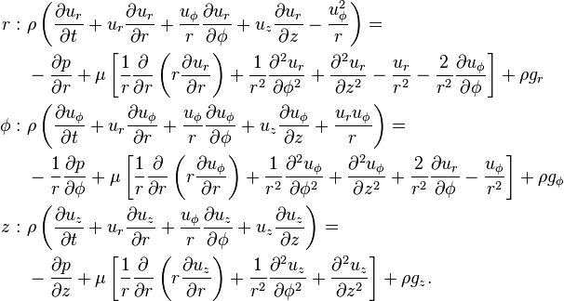 |  | Equation of continuity  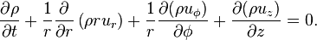
Assumptions | Implications
Flow is steady, d/dt = 0 | $$\frac{∂v_{x}}{∂t}, \frac{∂v_{y}}{∂t}, \frac{∂v_{z}}{∂t},\frac{∂v_{r}}{∂t},\frac{∂v_{∅}}{∂t}=0$$
Plates are infinite in  - x/y direction  - x/z direction  - y/z direction  Parallel flow | - $v_{z}=0$  - $v_{y}=0$  - $v_{x}=0$
Incompressible, Newtonian, laminar, constant properties
No pressure gradient | $$\frac{∂P}{∂x} or\frac{∂P}{∂y} or \frac{∂P}{∂z}=0$$
2D | - $v_{y}=0$, $\frac{∂v_{y}}{∂y}=0$, $\frac{∂^{2}v_{y}}{∂y^{2}}=0$  - $v_{z}=0$, $\frac{∂v_{z}}{∂z}=0$, $\frac{∂^{2}v_{z}}{∂z^{2}}=0$  - $v_{z}=0$, $\frac{∂v_{z}}{∂z}=0$, $\frac{∂^{2}v_{z}}{∂z^{2}}=0$
Gravity acts in the –x,-y, or -z direction | $$g_{x} or g_{y} or g_{z}= -g$$  $$The other two g components are therefore 0$$
No slip at wall | $$v_{x}=v_{y}=v_{z}=0$$
At the free surface (x = h), there is negligible shear | - $\frac{∂v_{y}}{∂x}=0$  - $\frac{∂v_{z}}{∂x}=0$  - $\frac{∂v_{z}}{∂y}=0$
The pipe is infinitely long in the z-direction, parallel flow | $$u_{r}=0 \frac{∂{(ru}_{r})}{∂r}=0$$
The velocity field is axisymmetric with no swirl | u_{θ} = 0 and all partial derivatives with respect to θ are zero
Conduction
k – thermal conductivity, in units of power per distance per temperature (Btu / (hr ft F)
α – thermal diffusivity, in units of area per time (ft^2 / hour)
Thermal Resistance
$$q=\frac{∆T}{R}$$
Plane: $R=\frac{∆x}{kA}$ Cylinder: $R=\frac{∆r}{kA_{LM}}$Sphere: $R=\frac{∆r}{kA_{GM}} A_{GM}=\sqrt{A_{1}A_{2}} A_{LM}=\frac{A_{2}-A_{1}}{\ln{\frac{A_{2}}{A_{1}}}}$
Series resistance: $R_{total}=\sum{R}$ Parallel resistance: $\frac{1}{R_{total}}=\sum{\frac{1}{R}}$

Non-steady state conduction
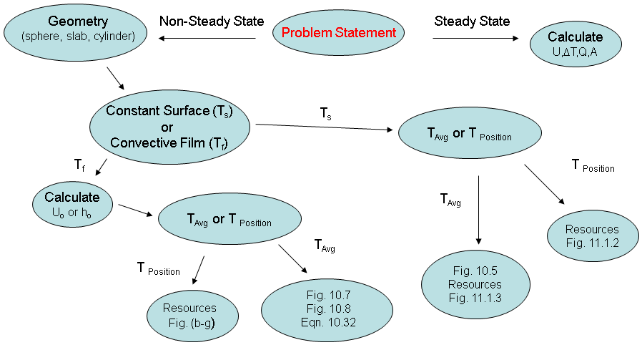

$$α=\frac{k}{ρC_{p}} F_{a}=\frac{αt_{T}}{r^{2}} (unitless)$$
T_{s} – constant average temperature of surface
T_{b} – average temperature of the slab/sphere at time t or at position r
T_{a} – initial temperature of the slab/sphere

Figure 10.5 Average temperatures during unsteady-state heating or cooling of a large slab, and infinitely long cylinder, or a sphere.
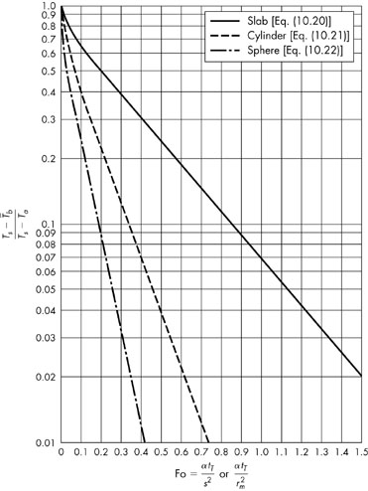 | For infinitely long (no end effects) cylinder:  $$θ=\frac{T_{s}-T_{b}}{T_{s}-T_{a}}$$  $$=0.692e^{-5.78F_{a}}+0.131e^{-30.5F_{a}}+0.0534e^{-74.9F_{a}}$$  For a sphere:  $$θ=\frac{T_{s}-T_{b}}{T_{s}-T_{a}}$$  $$=0.608e^{-9.87F_{a}}+0.152e^{-39.5F_{a}}+0.0676e^{-88.8F_{a}}$$
Biot number: $B_{i}=\frac{convection}{conduction}=\frac{hs}{k} for a flat plate, where s is half of the thickness$
$$B_{i}=\frac{hr}{k}, for a sphere, where r is the radius$$

For constant surface
To get time, based on all temperatures
Get θ Fig 10.5 to Get F₀ Get time

To get average temperature, based on time
Based on time, get F₀ Fig 10.5 t go get θ

For convective film
To get time, based on all temperatures
Calculate Re and Pr Get Nu Get h Get Bi && Get θ Fig 10.7/10.8 to Get F₀ Get time

To get average temperature, based on time
Calculate Re and Pr Get Nu Get h Get Bi && Get F₀ Fig 10.7/10.8 to get θ based on F₀ and Bi

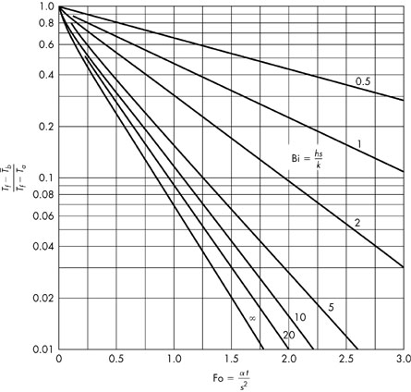
Figure 10.7 Change with time of the average temperature of a slab with external convective resistance.
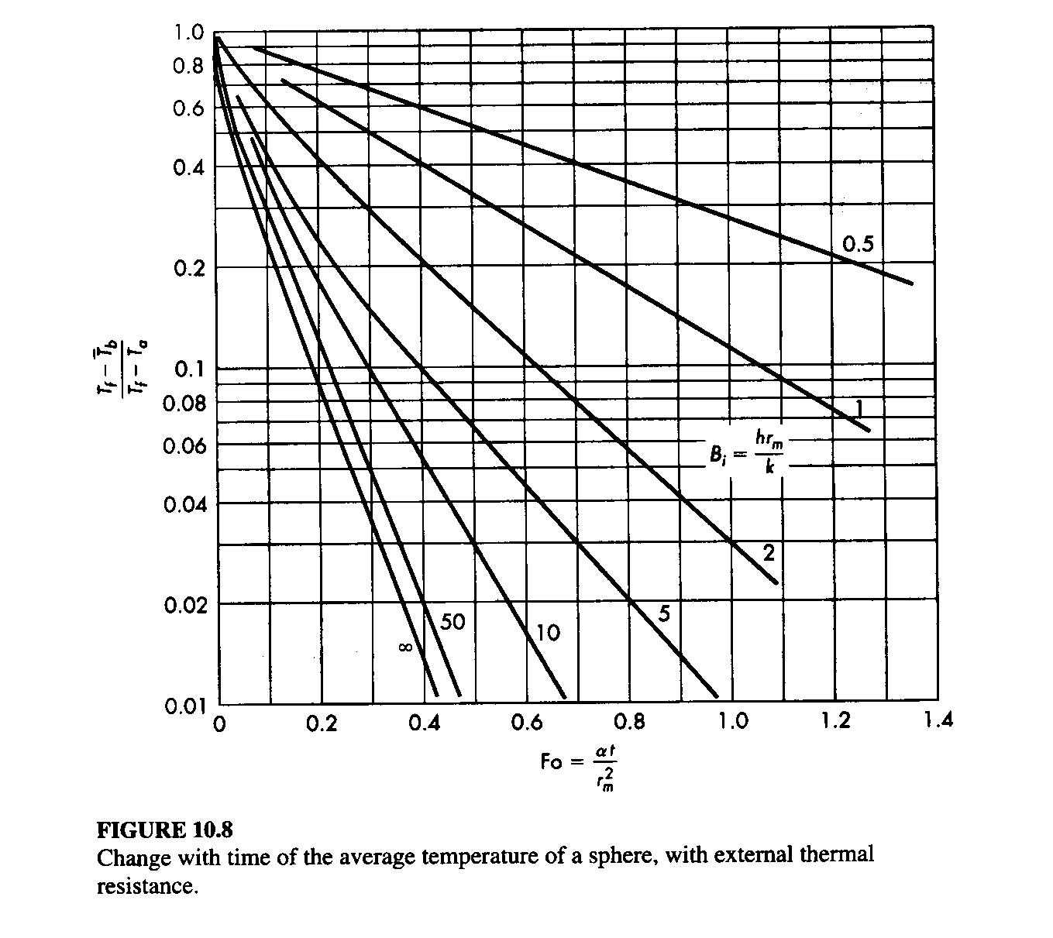
Convection
$$q=hA∆T$$
h is the individual heat transfer coefficient, obtained from empirical methods, power per area per temperature
$$N_{Nu}=\frac{hD}{k}=0.023N_{Re}^{0.8}N_{Pr}^{0.333}∅^{0.14}=0.023{\left(\frac{Dρv}{μ}\right)}^{0.8}{\left(\frac{C_{p}μ}{k}\right)}^{0.333}{\left(\frac{μ}{μ_{w}}\right)}^{0.14}$$

For flow in pipes, 0.6<N_{Pr}<16700
$$N_{St}N_{Pr}^{2/3}∅^{0.14}=\left(\frac{h}{C_{p}ρv}\right){\left(\frac{C_{p}μ}{k}\right)}^{2/3}{\left(\frac{μ}{μ_{w}}\right)}^{0.14}=0.023{\left(\frac{Dρv}{μ}\right)}^{-0.2}$$
$$j=0.023{\left(\frac{Dρv}{μ}\right)}^{-0.2}=\frac{f}{2}$$

External forced convection normal to tubes
$$N_{Pr}^{0.333}N_{Nu}=0.35+0.56N_{Re}^{0.52}$$

Flow past single sphere
$$N_{Nu}=2.0+0.6N_{Re}^{0.50}N_{Pr}^{0.333}$$
$$\frac{1}{U_{0}A_{0}}=\frac{1}{h_{0}A_{0}}+\frac{{∆r}_{insul}}{A_{lm}k_{insul}}+\frac{{∆r}_{pipe}}{A_{lm}k_{pipe}}+\frac{1}{h_{i}A_{i}}$$
$$\frac{1}{U_{0}}=\frac{D_{0}}{D_{i}h_{i}}+\frac{D_{0}ln⁡(D_{0}/D_{i)}}{2k_{w}}+\frac{1}{h_{0}}=\frac{D_{0}}{D_{i}h_{i}}+\frac{D_{0}(D_{0}-D_{i})}{D_{LM}2k_{w}}+\frac{1}{h_{0}}$$
Where k_{w} is the thermal conductivity of the pipe wall and $\frac{D_{0}-D_{i}}{2}$ is the wall thickness x_{w}
$$\frac{1}{U_{i}}=\frac{1}{h_{i}}+\frac{D_{i}ln⁡(D_{0}/D_{i)}}{2k_{w}}+\frac{D_{i}}{{D_{0}h}_{0}}$$

Concentric pipe
$$Q=UA∆T_{LM}$$
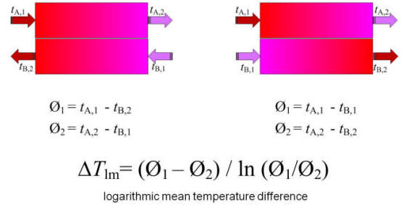
If $∅_{1}=∅_{2}, then ∆T_{LM}=∅_{1}$

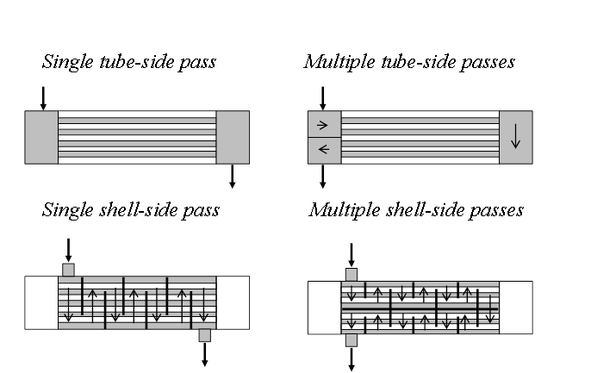
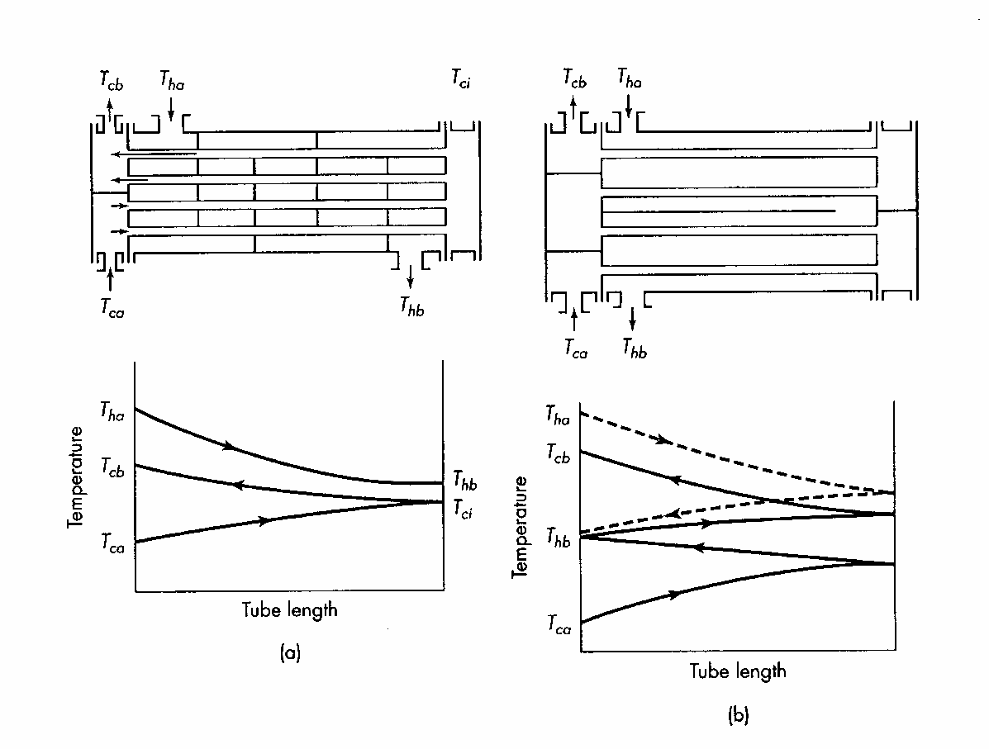
$$Z=\frac{T_{ha}-T_{hb}}{T_{cb}-T_{ca}} η=\frac{T_{ca}-T_{ca}}{T_{ha}-T_{ca}}$$
h- shell
c- tube
a- in
b- out

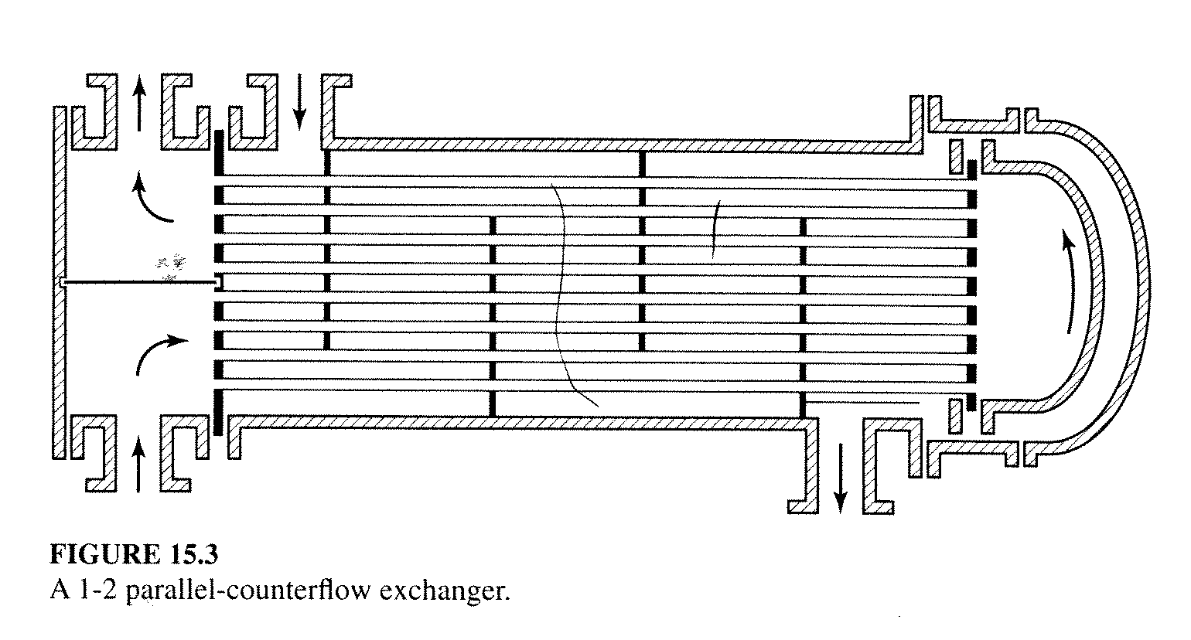
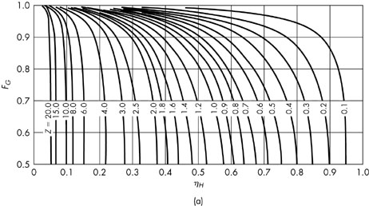
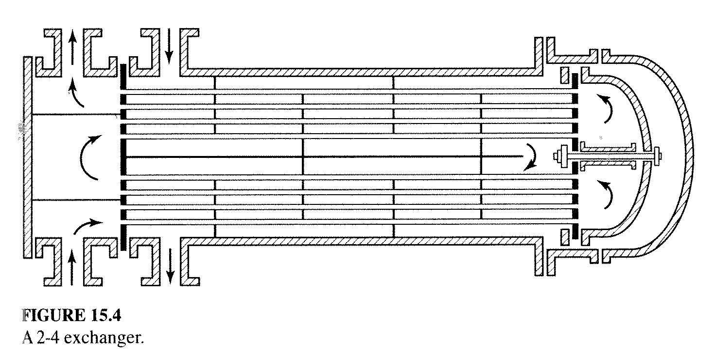
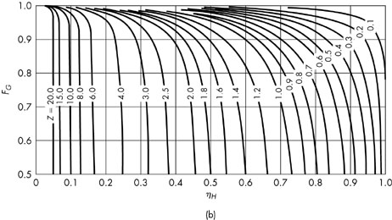
$$Q = U_{0}A_{0}F_{G}∆T_{LM}$$

