Liquid or solid mixture | Gas mixture
$$c=\frac{n}{V} c_{A}=\frac{n_{A}}{V} c_{B}=\frac{n_{B}}{V} x_{A}=\frac{c_{A}}{c}=\frac{n_{A}}{n} x_{B}=\frac{c_{B}}{c}=\frac{n_{B}}{n}$$  $$c_{A}+c_{B}=c x_{A}+x_{B}=1$$ | $$c_{A}=\frac{P_{A}}{RT} c_{B}=\frac{P_{B}}{RT} y_{A}=\frac{P_{A}}{P} y_{B}=\frac{P_{B}}{P}$$  $$c_{A}+c_{B}=c=\frac{P_{A}}{RT}+\frac{P_{B}}{RT}=\frac{P}{RT} y_{A}+y_{B}=1$$
$$ρ_{A}=c_{A}M_{A} y_{A} or x_{A}=\frac{\frac{ω_{A}}{M_{A}}}{\frac{ω_{A}}{M_{A}}+\frac{ω_{B}}{M_{B}}} mass fraction ω_{A}=\frac{x_{A}M_{A}}{x_{A}M_{A}+x_{B}M_{B}} or \frac{y_{A}M_{A}}{y_{A}M_{A}+y_{B}M_{B}}$$
$$mass average velocity v=\frac{\sum_{i=1}^{n}{ρ_{i}v_{i}}}{ρ} molar average velocity V=\frac{\sum_{i=1}^{n}{c_{i}V_{i}}}{c}$$

Fick’s law for molecular diffusion
$$J_{Az}=-D_{AB}\frac{dc_{A}}{dz}=-cD_{AB}\frac{dx_{A} or dy_{A} }{dz}=\frac{D_{AB}\left(c_{A1}-c_{A2}\right)}{z_{2}-z_{1}}=\frac{cD_{AB}\left(x_{A1}-x_{A2}\right)}{z_{2}-z_{1}}$$
$$c_{A}=\frac{n_{A}}{V}=\frac{P_{A}}{RT} J_{Az}=\frac{D_{AB}\left(P_{A1}-P_{A2}\right)}{z_{2}-z_{1}}$$
Convection
$$N_{A}=J_{A}+c_{A}v_{M}$$
$$J_{A}+J_{B}=0 c_{A}+c_{B}=c$$
$$N=J_{A}+c_{A}v_{M}+J_{B}+c_{B}v_{M}=c_{A}v_{M}+c_{B}v_{M}=cv_{M}=N_{A}+N_{B} v_{M}=\frac{N_{A}+N_{B}}{c}$$
$$N_{A}=J_{A}+\frac{c_{A}}{c}\left(N_{A}+N_{B}\right)$$
$$N_{A}=-cD_{AB}\frac{dx_{A}}{dz}+\frac{c_{A}}{c}\left(N_{A}+N_{B}\right) N_{B}=-cD_{BA}\frac{dx_{B}}{dz}+\frac{c_{B}}{c}\left(N_{A}+N_{B}\right)$$
$$N_{A}=k_{c}\left(c_{L1}-c_{Li}\right)$$
$$K=\frac{c_{Li}}{c_{i}}$$
Equimolar counterdiffusion in gases
$$J_{Az}=-J_{Bz}$$
$$c=c_{A}+c_{B} dc_{A}=-dc_{B}$$
$$J_{Az}=-D_{AB}\frac{dc_{A}}{dz}=-J_{Bz}=D_{BA}\frac{dc_{B}}{dz}$$
$$D_{AB}=D_{BA}$$
$$N_{A}=-c\left(D_{AB}+ε_{M}\right)\frac{dx_{A}}{dz}+x_{A}(N_{A}+N_{B})$$
If A is diffusing in stagnant, nondiffusing B, $N_{B}=0$
$$N_{A}=-cD_{AB}\frac{dx_{A}}{dz}+\frac{c_{A}}{c}N_{A}=-D_{AB}\frac{dc_{A}}{dz}+x_{A}N_{A}$$
$$N_{A}=-\frac{D_{AB}}{1-x_{A}}\frac{dc_{A}}{dz}=-\frac{cD_{AB}}{c-c_{A}}\frac{dc_{A}}{dz}$$
$$N_{A} dz=\frac{cD_{AB}}{c-c_{A}}dc_{A} N_{A}\left(z_{2}-z_{1}\right)=cD_{AB}\ln{\frac{c-c_{A2}}{c-c_{A1}}}=cD_{AB}\ln{\frac{1-x_{A2}}{1-x_{A1}}}$$
$$N_{A}=-\frac{D_{AB}}{RT}\frac{dP_{A}}{dz}+\frac{P_{A}}{P}N_{A} N_{A}\left(1-\frac{P_{A}}{P}\right)=-\frac{D_{AB}}{RT}\frac{dP_{A}}{dz}$$
$$N_{A}=\frac{D_{AB}P}{RT\left(z_{2}-z_{1}\right)}\ln{\frac{P-P_{A1}}{P-P_{A2}}} P=P_{A1}+P_{B1}=P_{A2}+P_{B2}$$
$$P_{BM}=\frac{P_{B2}-P_{B1}}{\ln{\frac{P_{B2}}{P_{B1}}}}=\frac{P_{A1}-P_{A2}}{\ln{\frac{P-P_{A2}}{P-P_{A1}}}} N_{A}=\frac{D_{AB}P}{RT\left(z_{2}-z_{1}\right)P_{BM}}P_{A1}-P_{A2}$$
Diffusion from a sphere
$$N_{A}=\frac{\overline{N_{A}}}{Area}$$
$$N_{A}=-4πr^{2}D\frac{dC_{A}}{dr}$$
$$\frac{{dN}_{A}}{dr}=0=\frac{D}{r^{2}}\frac{d}{dr}\left(r^{2}\frac{dC_{A}}{dr}\right)=0$$
$$\frac{d}{dr}\left(r^{2}\frac{dC_{A}}{dr}\right)=0 BC:r=R C_{A}=C_{AR} r=∞ C_{A}=0$$
$$r^{2}\frac{dC_{A}}{dr}=A_{1} \frac{dC_{A}}{dr}=\frac{A_{1}}{r^{2}} C_{A}=A_{2}-\frac{A_{1}}{r} A_{1}=-\frac{C_{AR}}{R} A_{2}=0$$
$$C_{A}=C_{AR}\frac{R}{r}$$
$$N_{A@R}=-D{\frac{dC_{A}}{dr}}_{R}=-DC_{AR}R*-{\frac{1}{r^{2}}}_{R}=\frac{C_{AR}D}{R}$$
$$dM=-N*A*dt$$
$$ρdV=-N*A*dt$$
$$ρ4πr^{2}dr=\frac{C_{AR}D}{r}*4πr^{2}*dt$$
$$\int_{R}^{0}{ρrdr}=\frac{C_{AR}D}{r}t t=\frac{ρR^{2}}{2C_{AR}D}$$
Diffusion through a conduit of nonuniform cross-sectional area
$$r=\frac{r_{2}-r_{1}}{z_{2}-z_{1}}z+r_{1} N_{A}=\frac{\overline{N_{A}}(\frac{kgmol}{s})}{πr^{2}} =\frac{-D_{AB}dP_{A}}{RT\left(1-\frac{P_{A}}{P}\right)dr}=\frac{\overline{N_{A}}}{π{\left(\frac{r_{2}-r_{1}}{z_{2}-z_{1}}z+r_{1}\right)}^{2}}$$
$$Re=\frac{inertial forces}{viscous forces}= \frac{ρLv}{μ}$$
$$Sc=\frac{viscous difusion rate}{molecular diffusion rate}= \frac{μ}{ρD_{AB}}$$
Sherwood number $N_{Sh}=\frac{convective mass transfer coefficient}{diffusive mass transfer coefficient}=\frac{k_{c}'L}{D_{AB}}=\frac{k_{c}y_{BM}L}{D_{AB}}=\frac{k_{x}'L}{cD_{AB}}=f\left(Re, Sc\right)$

Equation for diffusion in liquids
$${equimolar counterdiffusion N}_{A}=\frac{D_{AB}\left(c_{A1}-c_{A2}\right)}{z_{2}-z_{1}}=\frac{D_{AB}c_{Av}\left(x_{A1}-x_{A2}\right)}{z_{2}-z_{1}}$$
$${diffusion A thorugh nondiffusing B N}_{A}=\frac{D_{AB}c_{Av}\left(x_{A1}-x_{A2}\right)}{\left(z_{2}-z_{1}\right)x_{BM}}=\frac{D_{AB}\left(c_{A1}-c_{A2}\right)}{z_{2}-z_{1}} x_{BM}=\frac{x_{B2}-x_{B1}}{\ln{\frac{x_{B2}}{x_{B1}}}}$$
Diffusion in solids
$$c_{A}=solubility\left(m^{3}solute per m^{3}\right)*\frac{P_{A}}{22.414} (\frac{kg mol A}{m^{3}solid})$$
$$N_{A}=\frac{D_{AB}S\left(P_{A1}-P_{A2}\right)}{22.414(z_{2}-z_{1})}$$
$$Y=\frac{c_{1}-c}{c_{1}-c_{0}}$$
$$c=c_{0} t=0 x=x_{1} Y=1$$
$$c=c_{1} t=t x=0 Y=0$$
$$c=c_{1} t=t x=2x_{1} Y=0$$

Heat transfer | Mass transfer
$$Y=\frac{T_{1}-T}{T_{1}-T_{o}}$$  $$X=\frac{αt}{x_{1}^{2}}$$  $$\frac{x}{2\sqrt{αt}}$$  $$m=\frac{k}{hx_{1}}$$  $$\frac{h}{k}\sqrt{αt}$$  $$n=\frac{x}{x_{1}}$$ | $$Y=\frac{c_{1}/K-c}{c_{1}/K-c_{o}}$$  $$X=\frac{D_{AB}t}{x_{1}^{2}}$$  $$\frac{x}{2\sqrt{D_{AB}t}}$$  $$m=\frac{D_{AB}}{Kk_{c}x_{1}}$$  $$\frac{Kk_{c}}{D_{AB}}\sqrt{D_{AB}t}$$  $$n=\frac{x}{x_{1}}$$

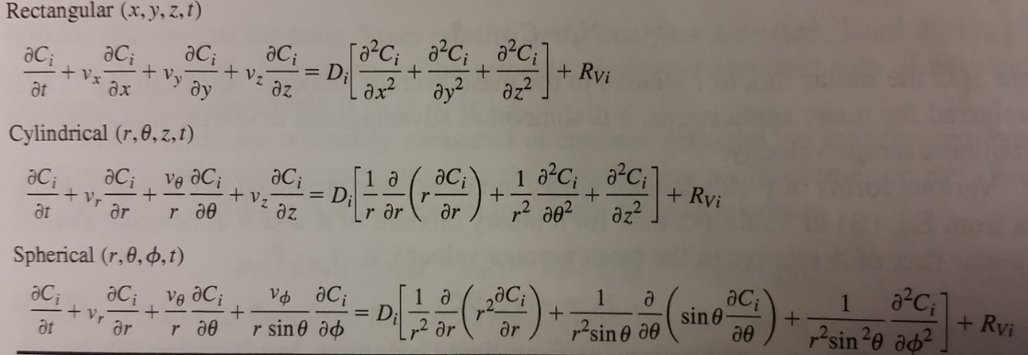
Initial conditions (IC)
$$C_{A}\left(t=0, x,y,z\right)=costant$$
Boundary conditions (BC)
$$C_{A}\left(z=z_{s}, x,y,t\right)=costant$$

Boundary conditions (BC)
$$\frac{dC_{A}}{dz}=costant, or constant= 0$$
$$-D\frac{dC_{A}}{dz}=k(C_{A∞}-C_{As})$$

Different types of fluxes
 | Mass flux (kg/s/m^2) | Molar flux (kg/s/m^2)
Relative to fixed coordinates | $$n_{A}=ρ_{A}v_{A}$$ | $$N_{A}=c_{A}v_{A}$$
Relative to molar average velocity vm | $$j_{A}=ρ_{A}(v_{A}-v_{M})$$ | $$j_{A}=c_{A}(v_{A}-v_{M})$$
Relative to mass average velocity v | $$j_{A}=ρ_{A}(v_{A}-v)$$ | $$j_{A}=c_{A}(v_{A}-v)$$
Relations between the fluxes above
$$N_{A}+N_{B}=cv_{M}$$ | $$N_{A}=n_{A}/M_{A}$$ | $$N_{A}=J_{A}+c_{A}V$$
$$J_{A}+J_{B}=0$$ | $$J_{A}=j_{A}/M_{A}$$ | $$n_{A}+n_{B}=ρv$$
$$j_{A}+j_{B}=0$$ | $$N_{A}=J_{A}+c_{A}v_{M}$$ | $$n_{A}=j_{A}+ρ_{A}V$$
$$J_{A}=-cD_{AB}\frac{{dx}_{A}}{dz} j_{A}=-ρD_{AB}\frac{{dw}_{A}}{dz}$$

General mole balance $\overset{⃑}{∇}∙\overset{⃑}{N}+\frac{∂C_{A}}{∂t}=R_{A}$
$$N_{A}=-D_{AB}\frac{dc_{A}}{dz}+(x_{A} or y_{A})\left(N_{A}+N_{B}\right)$$

Spherical coordinates (typical 1D transport) $\overset{⃑}{∇}∙\overset{⃑}{N}=\frac{1}{r^{2}}\frac{∂\left(r^{2}N\right)}{∂r} N_{A}=-D_{AB}\frac{dc_{A}}{dr}+(x_{A} or y_{A})\left(N_{A}+N_{B}\right)$
If dilute or if counterdiffusive $N_{A}=-D_{AB}\frac{dc_{A}}{dr}$
If no reaction, $\frac{∂C_{A}}{∂t}=-\overset{⃑}{∇}∙\overset{⃑}{N}=-\frac{1}{r^{2}}\frac{∂\left(r^{2}N\right)}{∂r}=\frac{1}{r^{2}}\frac{∂\left(r^{2}D_{AB}\frac{dc_{A}}{dr}\right)}{∂r}=\frac{D_{AB}}{r^{2}}[2r\frac{dc_{A}}{dr}+r^{2}\frac{d^{2}c_{A}}{dr^{2}}]$
If steady state with reaction, $\overset{⃑}{∇}∙\overset{⃑}{N}=R_{A}$ if steady state without reaction, $\overset{⃑}{∇}∙\overset{⃑}{N}=0$
Typical ICs, t=0, $C_{A}=0$Typical BCs, r=R, $C_{A}=C_{A0} r=0, \frac{dC_{A}}{dr}=0$

Cartesian coordinates (can be any dimension) $\overset{⃑}{∇}∙\overset{⃑}{N}=\frac{∂N}{∂z} N_{A}=-D_{AB}\frac{dc_{A}}{dz}+(x_{A} or y_{A})\left(N_{A}+N_{B}\right)$
If dilute or if counterdiffusive $N_{A}=-D_{AB}\frac{dc_{A}}{dz}$
If no reaction, $\frac{∂C_{A}}{∂t}=-\overset{⃑}{∇}∙\overset{⃑}{N}=-\frac{∂N}{∂z}=\frac{∂\left(D_{AB}\frac{dc_{A}}{dz}\right)}{∂z}=D_{AB}\frac{d^{2}c_{A}}{dz^{2}}$
If steady state with reaction, $\overset{⃑}{∇}∙\overset{⃑}{N}=R_{A}$ if steady state without reaction, $\overset{⃑}{∇}∙\overset{⃑}{N}=0$
Typical ICs, t=0, $C_{A}=0$
Typical BCs, z=something, $C_{A} or x_{A}=something$

Cylindrical coordinates (can be 1D radial, or 2D axial) $\overset{⃑}{∇}∙\overset{⃑}{N}=\frac{∂N}{∂z}+\frac{1}{r}\frac{∂(rN)}{∂r}$
$$N_{Ar}=-D_{AB}\frac{dc_{A}}{dr} N_{Az}=c_{A}v_{z}$$
If no reaction, $\frac{∂C_{A}}{∂t}=-\overset{⃑}{∇}∙\overset{⃑}{N}=-\frac{∂N}{∂z}-\frac{1}{r}\frac{∂(rN)}{∂r}$
If steady state with reaction, $\overset{⃑}{∇}∙\overset{⃑}{N}=R_{A}$ if steady state without reaction, $\overset{⃑}{∇}∙\overset{⃑}{N}=0=\frac{∂N}{∂z}+\frac{1}{r}\frac{∂(rN)}{∂r}$
Typical ICs, t=0, $C_{A}=0$
Typical BCs, z or r=something, $C_{A} or x_{A}=something \frac{∂C_{A}}{∂r}=0 at r=0, symmetry$

Equimolar counterdiffusion
$$N_{A}=k_{y}^{'}\left(y_{AG}-y_{Ai}\right)=k_{x}^{'}\left(x_{Ai}-x_{AL}\right)=K_{y}^{'}\left(y_{AG}-y_{A}^{*}\right)=K_{x}^{'}\left(x_{A}^{*}-x_{AL}\right)$$
$$-\frac{k_{x}^{'}}{k_{y}^{'}}=\frac{\left(y_{AG}-y_{Ai}\right)}{\left(x_{AL}-x_{Ai}\right)}$$
$$y_{AG}-y_{A}^{*}=\left(y_{AG}-y_{Ai}\right)+(y_{Ai}-y_{A}^{*})$$  $$m^{'}=\frac{y_{Ai}-y_{A}^{*}}{x_{Ai}-x_{AL}}$$  $$\frac{1}{K_{y}^{'}}=\frac{1}{k_{y}^{'}}+\frac{m^{'}}{k_{x}^{'}}$$  If m’ small, gas phase controlling.  $$\frac{1}{K_{y}^{'}}=\frac{1}{k_{y}^{'}}$$ | $$x_{A}^{*}-x_{AL}=\left(x_{A}^{*}-x_{Ai}\right)+\left(x_{Ai}-x_{AL}\right)$$  $$m^{''}=\frac{y_{AG}-y_{Ai}}{x_{A}^{*}-x_{Ai}}$$  $$\frac{1}{K_{x}^{'}}=\frac{1}{{m^{''}k}_{y}^{'}}+\frac{1}{k_{x}^{'}}$$  If m’’ big, gas phase controlling.  $$\frac{1}{K_{x}^{'}}=\frac{1}{k_{x}^{'}}$$
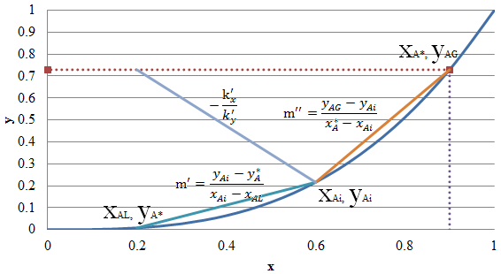
A diffusing through stagnant B
$$N_{A}=\frac{k_{y}^{'}\left(y_{AG}-y_{iM}\right)}{{\left(1-y_{A}\right)}_{iM}}=\frac{k_{x}^{'}\left(x_{iM}-x_{AL}\right)}{{\left(1-x_{A}\right)}_{iM}}=k_{y}\left(y_{AG}-y_{Ai}\right)=k_{x}\left(x_{Ai}-x_{AL}\right)$$
$$N_{A}=\frac{K_{y}^{'}\left(y_{AG}-y_{A}^{*}\right)}{{\left(1-y_{A}\right)}_{*M}}=\frac{K_{x}^{'}\left(x_{A}^{*}-x_{AL}\right)}{{\left(1-x_{A}\right)}_{*M}}=K_{y}\left(y_{AG}-y_{A}^{*}\right)=K_{x}\left(x_{A}^{*}-x_{AL}\right)$$
$$-\frac{k_{x}}{k_{y}}=\frac{\frac{-k_{x}^{'}}{{\left(1-x_{A}\right)}_{iM}}}{\frac{k_{y}^{'}}{{\left(1-y_{A}\right)}_{iM}}}=\frac{\left(y_{AG}-y_{Ai}\right)}{\left(x_{AL}-x_{Ai}\right)}$$
$$k_{y}=\frac{k_{y}^{'}}{{\left(1-y_{A}\right)}_{iM}}$$  $${\left(1-y_{A}\right)}_{iM}=\frac{\left(1-y_{Ai}\right)-(1-y_{AG})}{\ln{\frac{1-y_{Ai}}{1-y_{AG}}}}$$  $$K_{y}=\frac{K_{y}^{'}}{{\left(1-y_{A}\right)}_{*M}}$$  $${\left(1-y_{A}\right)}_{*M}=\frac{\left(1-y_{A*}\right)-(1-y_{AG})}{\ln{\frac{1-y_{A*}}{1-y_{AG}}}}$$  $$\frac{1}{\frac{K_{y}^{'}}{{\left(1-y_{A}\right)}_{*M}}}=\frac{1}{\frac{k_{y}^{'}}{{\left(1-y_{A}\right)}_{iM}}}+\frac{m^{'}}{\frac{k_{x}^{'}}{{\left(1-x_{A}\right)}_{iM}}}$$ | $$k_{x}=\frac{k_{x}^{'}}{{\left(1-x_{A}\right)}_{iM}}$$  $${\left(1-x_{A}\right)}_{iM}=\frac{\left(1-x_{AL}\right)-(1-x_{Ai})}{\ln{\frac{1-x_{AL}}{1-x_{Ai}}}}$$  $$K_{x}=\frac{K_{x}^{'}}{{\left(1-x_{A}\right)}_{*M}}$$  $${\left(1-x_{A}\right)}_{*M}=\frac{\left(1-x_{AL}\right)-(1-x_{A*})}{\ln{\frac{1-x_{AL}}{1-x_{A*}}}} \\ \frac{1}{\frac{K_{x}^{'}}{{\left(1-x_{A}\right)}_{*M}}}=\frac{1}{\frac{m^{''}k_{y}^{'}}{{\left(1-y_{A}\right)}_{iM}}}+\frac{1}{\frac{k_{x}^{'}}{{\left(1-x_{A}\right)}_{iM}}}$$
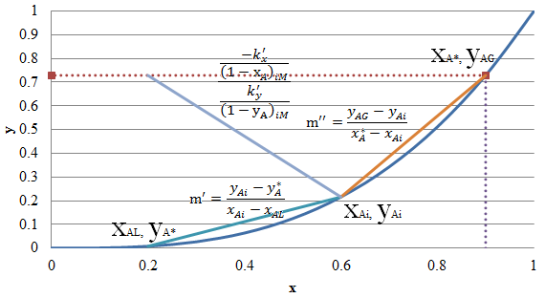

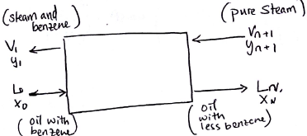 | Stripping (transfer of solute from L to V)  $$P_{i}=H_{i}x_{i} y_{i}=\frac{H_{i}}{P_{tot}}x_{i}$$  $$L^{'}=L_{0}\left(1-x_{0}\right)$$  $$L^{'}\frac{x_{0}}{1-x_{0}}+V^{'}\frac{y_{n+1}}{1-y_{n+1}}=L^{'}\frac{x_{n}}{1-x_{n}}+V^{'}\frac{y_{1}}{1-y_{1}}$$  $$V=\frac{V^{'}}{1-y_{n+1}}$$  $$N=\frac{\ln\left[\frac{x_{0}-\frac{y_{N+1}}{m}}{x_{N}-\frac{y_{N+1}}{m}}\left(1-A\right)+A\right]}{\ln{\frac{1}{A}}}$$
Absorption (transfer of solute from V to L)
$$L_{min}^{'}\frac{x_{L}}{1-x_{L}}+V^{'}\frac{y_{1}}{1-y_{1}}=L_{min}^{'}\frac{x_{1}}{1-x_{1}}+V^{'}\frac{y_{2}}{1-y_{2}}$$
$$V^{'}=V_{1}(1-y_{1})$$
$$N=\frac{\ln\left[\frac{y_{N+1}-mx_{0}}{y_{1}-mx_{0}}\left(1-\frac{1}{A}\right)+\frac{1}{A}\right]}{\ln{A}}$$
$$A=\sqrt{\frac{L_{N}L_{0}}{m^{2}V_{N+1}V_{1}}}$$
Plate absorption towers $L^{'}\frac{x_{0}}{1-x_{0}}+V^{'\frac{y_{N+1}}{1-y_{N+1}}}=L^{'}\frac{x_{N}}{1-x_{N}}+V^{'\frac{y_{1}}{1-y_{1}}}$ Packed column $L^{'}\frac{x}{1-x}+V'\frac{y_{1}}{1-y_{1}}=L^{'}\frac{x_{1}}{1-x_{1}}+V'\frac{y}{1-y}$
For stripping (transfer of solute from L to V) $N=\frac{\ln\left[\frac{x_{2}-\frac{y_{1}}{m}}{x_{1}-\frac{y_{1}}{m}}\left(1-A\right)+A\right]}{\ln{\frac{1}{A}}}$
For absorption (transfer of solute from V to L) $N=\frac{\ln\left[\frac{y_{1}-mx_{2}}{y_{2}-mx_{2}}\left(1-\frac{1}{A}\right)+\frac{1}{A}\right]}{\ln{A}}$
$$A=\frac{L}{mV} dA=aSdz$$
a is the interfacial area in m² per m³ volume of packed section S is the cross-sectional area of the tower.
$$d\left(Vy\right)=d\left(Lx\right)$$
$$z=\int_{y_{2}}^{y_{1}}{\frac{Vdy}{\frac{K_{y}^{'}aS}{{\left(1-y\right)}_{*M}}\left(1-y\right)\left(y-y^{*}\right)}}=\int_{x_{2}}^{x_{1}}{\frac{Ldx}{\frac{K_{x}^{'}aS}{{\left(1-x\right)}_{*M}}\left(1-x\right)\left(x^{*}-x\right)}}$$
$$z=\int_{y_{2}}^{y_{1}}{\frac{Vdy}{\frac{k_{y}^{'}aS}{{\left(1-y\right)}_{iM}}\left(1-y\right)\left(y-y_{i}\right)}}=\int_{x_{2}}^{x_{1}}{\frac{Ldx}{\frac{k_{x}^{'}aS}{{\left(1-x\right)}_{iM}}\left(1-x\right)\left(x_{i}-x\right)}}$$
if dilute
$$z=[\frac{V}{K_{y}^{'}aS}\frac{{\left(1-y\right)}_{*M}}{\left(1-y\right)}]\int_{y_{2}}^{y_{1}}{\frac{dy}{\left(y-y^{*}\right)}}=[\frac{L}{K_{x}^{'}aS}\frac{{\left(1-x\right)}_{*M}}{\left(1-x\right)}]\int_{x_{2}}^{x_{1}}{\frac{dx}{\left(x^{*}-x\right)}}$$
$$z=[\frac{V}{k_{y}^{'}aS}\frac{{\left(1-y\right)}_{iM}}{\left(1-y\right)}]\int_{y_{2}}^{y_{1}}{\frac{dy}{\left(y-y_{i}\right)}}=[\frac{L}{k_{x}^{'}aS}\frac{{\left(1-x\right)}_{iM}}{\left(1-x\right)}]\int_{y_{2}}^{y_{1}}{\frac{dx}{\left(x_{i}-x\right)}}$$
$$\frac{{\left(1-y\right)}_{iM}}{\left(1-y\right)}=\frac{{\left(1-y\right)}_{*M}}{\left(1-y\right)}=\frac{{\left(1-x\right)}_{iM}}{\left(1-x\right)}=\frac{{\left(1-x\right)}_{*M}}{\left(1-x\right)}=1$$
$$\frac{V}{S}\left(y_{1}-y_{2}\right)=k_{y}^{'}az{\left(y-y_{i}\right)}_{M}$$
$$\frac{L}{S}\left(x_{1}-x_{2}\right)=k_{x}^{'}az{\left(x_{i}-x\right)}_{M}$$
$$\frac{V}{S}\left(y_{1}-y_{2}\right)=K_{y}^{'}az{\left(y-y^{*}\right)}_{M}$$
$$\frac{L}{S}\left(x_{1}-x_{2}\right)=K_{x}^{'}az{\left(x^{*}-x\right)}_{M}$$
Concentrated solutions, stagnant B
$$z=H_{OG}\int_{y_{2}}^{y_{1}}{\frac{{\left(1-y\right)}_{*M}dy}{\left(1-y\right)\left(y-y^{*}\right)}}=H_{OG}N_{OG} H_{OG}=\frac{V}{K_{y}^{'}aS}=\frac{V}{K_{y}a{\left(1-y\right)}_{*M}S}$$
$$z=H_{OL}\int_{x_{2}}^{x_{1}}{\frac{{\left(1-x\right)}_{*M}dx}{\left(1-x\right)\left(x^{*}-x\right)}}=H_{OL}N_{OL} H_{OL}=\frac{V}{K_{x}^{'}aS}=\frac{V}{K_{x}a{\left(1-x\right)}_{*M}S}$$
$$z=H_{G}\int_{y_{2}}^{y_{1}}{\frac{{\left(1-y\right)}_{iM}dy}{\left(1-y\right)\left(y-y_{i}\right)}}=H_{G}N_{G} H_{G}=\frac{V}{k_{y}^{'}aS}=\frac{V}{k_{y}a{\left(1-y\right)}_{iM}S}$$
$$z=H_{L}\int_{x_{2}}^{x_{1}}{\frac{{\left(1-x\right)}_{iM}dx}{\left(1-x\right)\left(x_{i}-x\right)}}=H_{L}N_{L} H_{L}=\frac{V}{k_{x}^{'}aS}=\frac{V}{k_{x}a{\left(1-x\right)}_{iM}S}$$
Dilute solutions
$$\frac{{\left(1-y\right)}_{iM}}{\left(1-y\right)}=\frac{{\left(1-y\right)}_{*M}}{\left(1-y\right)}=\frac{{\left(1-x\right)}_{iM}}{\left(1-x\right)}=\frac{{\left(1-x\right)}_{*M}}{\left(1-x\right)}=1$$
$$z=H_{OG}N_{OG}=H_{OG}\int_{y_{2}}^{y_{1}}{\frac{dy}{\left(y-y^{*}\right)}} N_{OG}=\frac{y_{1}-y_{2}}{{\left(y-y^{*}\right)}_{M}}$$
$$z=H_{OL}N_{OL}=H_{OL}\int_{x_{2}}^{x_{1}}{\frac{dx}{\left(x^{*}-x\right)}} N_{OL}=\frac{x_{1}-x_{2}}{{\left(x^{*}-x\right)}_{M}}$$
$$z=H_{G}N_{G}=H_{G}\int_{y_{2}}^{y_{1}}{\frac{dy}{\left(y-y_{i}\right)}} N_{G}=\frac{y_{1}-y_{2}}{{\left(y-y_{i}\right)}_{M}}$$
$$z=H_{L}N_{L}=H_{L}\int_{x_{2}}^{x_{1}}{\frac{dx}{\left(x_{i}-x\right)}} N_{G}=\frac{x_{1}-x_{2}}{{\left(x_{i}-x\right)}_{M}}$$
$$N_{OG}=\frac{1}{1-\frac{1}{A}}\ln\left[\frac{y_{1}-mx_{2}}{y_{1}-mx_{2}}\left(1-\frac{1}{A}\right)+\frac{1}{A}\right]$$
$$N_{OL}=\frac{1}{1-A}\ln\left[\frac{x_{2}-y_{1}/m}{x_{1}-y_{1}/m}\left(1-A\right)+A\right]$$
$$N_{OG}=\frac{N*\ln{A}}{1-\frac{1}{A}}$$
$$HETP=H_{OG}\frac{\ln{\frac{1}{A}}}{\frac{1-A}{A}}$$

Vapor-liquid separation
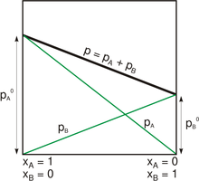 | Raoult’s law  $$p_{A}+p_{B}=P$$  $$P_{A}x_{A}+P_{B}\left(1-x_{A}\right)=P$$  $$y_{A}=\frac{p_{A}}{P}=\frac{P_{A}x_{A}}{P}$$  $$P_{A} and P_{B} are the vapor pressures of A and B$$
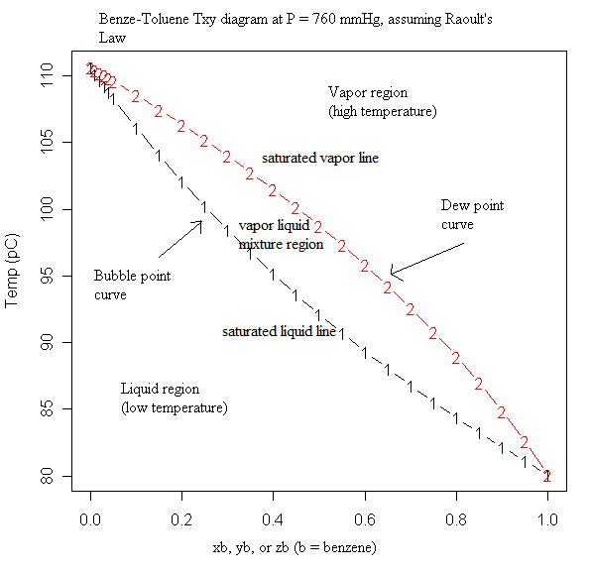
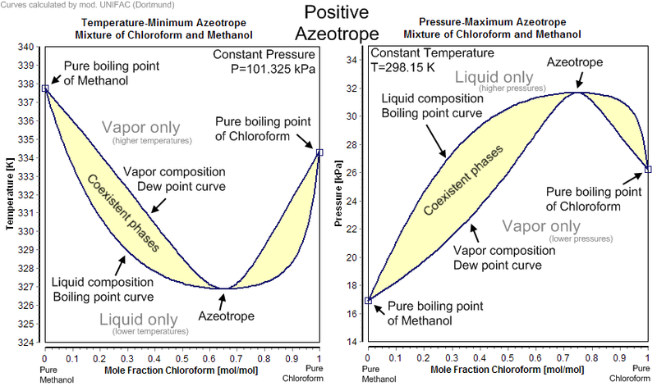
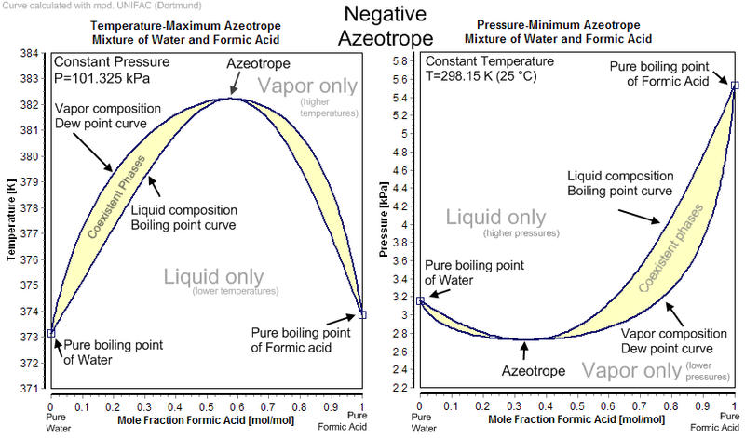
Relative volatility $α_{AB}=\frac{\frac{y_{A}}{x_{A}}}{\frac{y_{B}}{x_{B}}}=\frac{\frac{y_{A}}{x_{A}}}{\frac{{1-y}_{A}}{{1-x}_{A}}}=\frac{P_{A}}{P_{B}} y_{A}=\frac{α_{AB}x_{A}}{1+\left(α-1\right)x_{A}}$
Flash distillation ${Fx}_{F}=Vy+Lx=Vy+\left(F-V\right)x$
$$xL=\left(x-dx\right)\left(L-dL\right)+ydL=xL-xdL-Ldx+dxdL+yDL$$
$$\frac{dL}{L}=\frac{dx}{y-x} \int_{L_{2}}^{L_{1}}{\frac{dL}{L}}=\ln{\frac{L_{1}}{L_{2}}}=\int_{x_{2}}^{x_{1}}{\frac{dx}{y-x}}$$
$$L_{1}x_{1}=L_{2}x_{2}+\left(L_{1}-L_{2}\right)y_{av}$$
McCabe-Thiele Method
$$V_{n+1}+L_{n-1}=V_{n}+L_{n}$$
$$V_{n+1}y_{n+1}+L_{n-1}x_{n-1}=V_{n}y_{n}+L_{n}x_{n}$$

 |  | n-1
$$V_{n},y_{n}$$ | ↑ ↓  ↑ ↓ | $$L_{n-1},x_{n-1}$$  n
$$V_{n+1},y_{n+1}$$ | ↑ ↓  ↑ ↓ | $$L_{n},x_{n}$$  n+1

Enriching section  $$F=D+W$$  $${Fx}_{F}={Dx}_{D}+{Wx}_{W}$$  $$V_{n+1}=L_{n}+D$$  $$V_{n+1}y_{n+1}=L_{n}x_{n}+Dx_{D}$$  $$y_{n+1}=\frac{L_{n}}{V_{n+1}}x_{n}+D\frac{x_{D}}{V_{n+1}}=\frac{R}{R+1}x_{n}+\frac{x_{D}}{R+1}$$  $$R=\frac{L_{n}}{D}$$  Enriching line will intersect y=x line at xD, y=xD  Draw from xD, y=xD with the slope $\frac{L_{n}}{V_{n+1}} or\frac{R}{R+1}$ | Stripping section  $$V_{m+1}=L_{m}-W$$  $$V_{m+1}y_{m+1}=L_{m}x_{m}-Wx_{W}$$  $$y_{m+1}=\frac{L_{m}}{V_{m+1}}x_{m}-\frac{Wx_{W}}{V_{m+1}}$$  Enriching line will intersect y=x line at xW, y=xW  Draw from xD, y=xD with the slope $\frac{L_{m}}{V_{m+1}}$
Two lines intersect at a point, connect that point to xF, y=xF to form q line

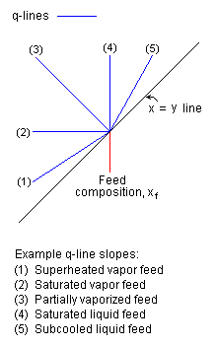 | $$q=\frac{H_{V}\left(dew point\right)-H_{F}\left(entrance conditions\right)}{H_{V}\left( dew point\right)-H_{L}\left(bubble/boiling point\right)}$$  H- enthalpy of feed  $$L_{m}=L_{n}+qF$$  $$V_{n}=V_{m}+\left(1-q\right)F$$  $$y=\frac{q}{q-1}x+\frac{x_{F}}{q-1}$$  q line will intersect y=x line at xF, y=xF
- H at entrance condition > H at bubble point (and dew point), q < 0, slope < 1
- H at entrance condition = H at dew point, q = 0, slope = 0
- H at entrance condition < H at bubble point, 0<q<1, slope < 0
- H at entrance condition = H at bubble point q=1, slope = infinite
- H at entrance condition < H at dew point, q>1, slope > 1

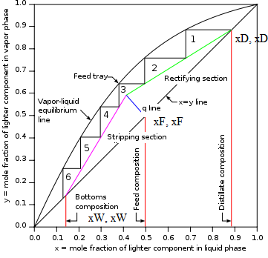  Reboiler is an equilibrium stage where there is both liquid and vapor leaving. Condenser is not because full condensation occurs. | x’ and y' represent pinch point, where the number of stages required becomes infinite, $\frac{R_{m}}{R_{m}+1}=\frac{x_{D}-y^{'}}{x_{D}-x^{'}}$. Typically want R = 1.2 Rm ~ 1.5 Rm  R = infinity, slope of the enriching section = 1  $$N_{m}=\frac{\log{\frac{x_{D}}{1-x_{D}}\frac{1-x_{W}}{x_{W}}}}{\log{α_{av}}}$$  Overall efficiency $E_{O}=\frac{number of idealtrays}{number of actual trays}$  Murphree tray efficiency $E_{M}=\frac{y_{n}-y_{n+1}}{y_{n}^{*}-y_{n+1}}$  if the operating line is straight with slope m  $$E_{O}=\frac{\log{1+E_{M}\left(\frac{mV}{L}-1\right)}}{\log{\frac{mV}{L}}}$$  $$H=H_{OG}N_{OG}$$  $$HETP=\frac{H_{OG}\ln{\frac{m}{\frac{L}{V}}}}{\frac{m}{\frac{L}{V}}-1}=\frac{Tray spacing T}{E_{O}}$$

Liquid-liquid and fluid-solid separations
Equilibrium relationships - 3 isotherms for adsorption
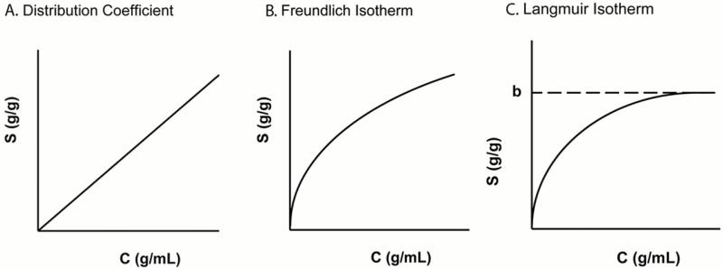 |  |  | Freundlich is favorable, Langmuir is strongly favorable.  $$q_{F}M+c_{F}S=qM+cS$$
$$q=Kc$$ | $$q={Kc}^{n}$$ | $$q=\frac{q_{0}c}{K+c}$$

Washing
Analogous to stripping where U (underflows) O (overflows)
$$recovery=1-\frac{x_{N} \left(outlet\right)}{x_{0} \left(inlet\right)}=\frac{x_{0}-x_{N}}{x_{0}-y_{N+1}}=\frac{{\left(\frac{1}{A}\right)}^{N+1}-\frac{1}{A}}{{\left(\frac{1}{A}\right)}^{N+1}-1} A=\frac{L}{mV}=\frac{U}{O}$$
V1, x1  ←  →  L0, N0, y0, B |  |  | V2, x2  ←  →  L1, N1, y1, B
$$L_{0}+V_{2}=L_{1}+V_{1}=M$$
$$L_{0}y_{A0}+V_{2}x_{A2}=L_{1}y_{A1}+V_{1}x_{A1}=Mx_{AM}$$
$$B=L_{0}N_{0}=L_{1}N_{1}=N_{M}M$$
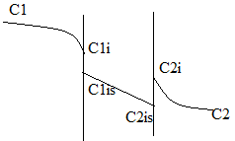 |  | $$N_{A}=k_{1}\left(C_{1}-C_{1i}\right)=\frac{DS}{L}\left(C_{1i}-C_{2i}\right)=k_{2}\left(C_{2}-C_{2i}\right)$$  $$D\left(diffusivity\right)*S(solubility)=P(permeability)$$  $$C_{1}-C_{1i}=\frac{N_{A}}{k_{1}}$$  $$C_{1i}-C_{2i}=\frac{N_{A}L}{P_{A}}$$  $$C_{2i}-C_{2}=\frac{N_{A}}{k_{2}}$$  $$N_{A}=\frac{C_{1}-C_{2}}{\frac{1}{k_{1}}+\frac{L}{P_{A}}+\frac{1}{k_{2}}}$$
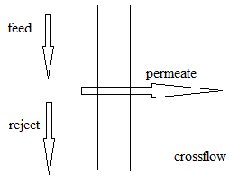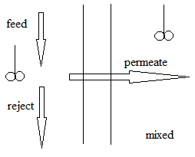
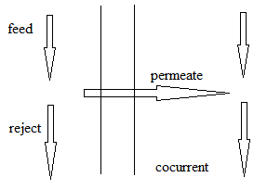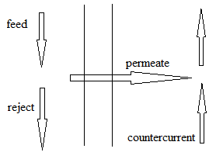
$$\frac{V_{A}}{A}=\frac{V_{P}y_{P}}{A}=\frac{P_{A}^{'}}{L}\left(P_{h}x_{0}-P_{l}y_{p}\right) \frac{V_{B}}{A}=\frac{V_{P}\left(1-y_{p}\right)}{A}=\frac{P_{B}^{'}}{L}\left(P_{h}(1-x_{0})-P_{l}(1-y_{p})\right)$$
$$α^{*}=\frac{P_{A}^{'}}{P_{B}^{'}} L_{f}=L_{0}+V_{p} θ=\frac{V_{p}}{L_{f}}$$
$$\frac{y_{p}}{1-y_{p}}=\frac{α^{*}[x_{0}-\frac{p_{l}}{p_{h}}y_{p}]}{\left(1-x_{0}\right)-\frac{p_{l}}{p_{h}}(1-y_{p})}$$
$$y_{p}=\frac{-b±\sqrt{b^{2}-4ac}}{2a}$$
$$a=1-α^{*} b=-1+α^{*}+\frac{p_{h}}{p_{l}}+\frac{x_{0}p_{h}}{p_{l}}\left(α^{*}-1\right) c=-\frac{α^{*}x_{0}p_{h}}{p_{l}}$$
$$L_{f}x_{f}=L_{0}x_{0}+V_{p}y_{p} x_{0}=\frac{x_{f}- θy_{p}}{1-θ} y_{p}=\frac{x_{f}-x_{0}\left(1-θ\right)}{θ} A=\frac{θL_{f}y_{p}}{\frac{P_{A}^{'}}{L}\left(p_{h}x_{0}-p_{l}y_{p}\right)}$$

