Lab Final Review Sheet

Thin-Layer Chromatography
- Nonpolar substance travels faster/farther than a polar substance because the TLC plate is made of silica, which is polar.
- Only conjugated compounds, compounds with successive double bonds, will appear under UV.
- Iodine (I₂) will form a complex with polar/reactive compounds and form a brown spot.
- Hexane is a nonpolar solvent, ethyl acetate is polar. Adjust the proportion of each to adjust the polarity of solvent.
  - If both mixtures are very polar, try using more nonpolar solvents (hexane).
  - If both mixtures are very nonpolar, try using more polar solvents (ethyl acetate).
- It is important to have the spotting line above the solvent level and the TLC plate not touching the wet filter paper, to prevent the compounds in the lanes from running sideways.
- Two different compounds could have the same or similar Rf values.
- The higher the polarity, the lower the Rf values.
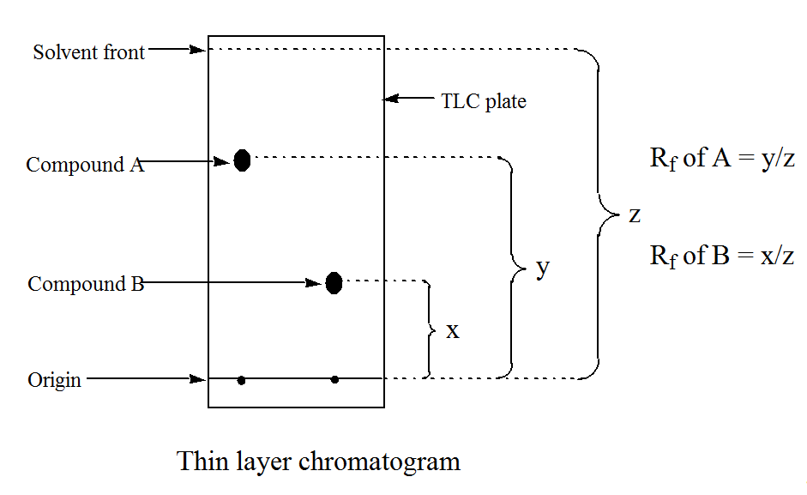
Ibuprofen Aspirin Acetaminophen Caffeine
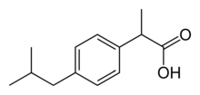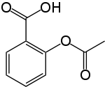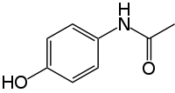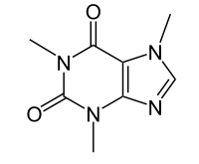

Polarity, from less to more. Rf values, from large to small
Aspirin, or acetylsalicylic acid, sometimes hydrolyzes to a small extent to form acetic acid and salicylic acid. So there might be a spot for salicylic acid on the TLC plate.

Liquid-liquid extraction
- Aqueous NaCl / brine- to “dry” the organic layer by removing excess water, due to the difference in concentration. Anhydrous salt is used after this
- HCl is to protonate. NaOH is to deprotonate.
- Protonated is less polar than deprotonated.
- For a compound containing acidic H, if pH > pKa, deprotonated. If pH < pKa, protonated.
- Strategies for separating different compounds using extraction:
  - Dissolve everything in organic solvent, such as ethyl acetate
  - Add in buffer to tune pH at the pKa of the buffer, creates 2 layers: organic layer which contains protonated compounds, and aqueous layer which contains deprotonated compounds. Then separate 2 layers.
  - If further separation is required in the organic layer, add HCl to protonate one species without protonating the other species. Then 2 layers are created and separated like above. (usually the aqueous layer would only contain one species, and the organic layer would contain the other species, or everything else)
  - If no further separation is required, protonate the aqueous layer by excess HCl, precipitate the compound. Add brine (sat. NaCl) to the organic layer to remove water, add anhydrous salt (sulfate) to remove more water, then evaporate the organic solvent by blowing a stream of air and heating.
 | Aspirin | Acetaminophen | Caffeine
Step 1 | Ethyl acetate: everything dissolved in organic layer
Step 2 K₂HPO₄ buffer | Organic  Protonated | Organic  Protonated | Aqueous  Deprotonated  Add HCl to protonate  Filter by vacuum
Step 3 KOH | Aqueous  Deprotonated  Add HCl to protonate  Filter by vacuum | Organic  Protonated  Dry with NaCl  Dry with Na₂SO₄  Evaporate organic
Adsorption chromatography- solute equilibrates between a gas mobile phase and a liquid stationary phase.
Partition chromatography- solute equilibrates between a gas mobile phase and a liquid stationary phase.
Ion-exchange chromatography- ions in mobile phase are attracted to counterions covalently attached to stationary phase
Size exclusion chromatography- different-sized solutes penetrate voids in stationary phase to different extents. Largest solutes are eluted first.
Affinity chromatography- solute in mobile phase interacts with specific groups covalently attached to stationary phase.

Column chromatography
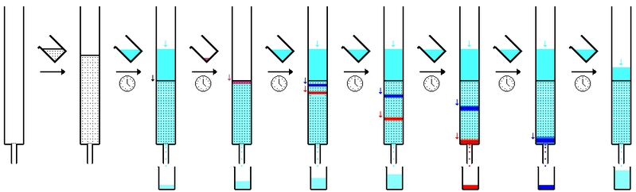
- Collected TLC samples to see if there are any compounds, which ones they are, etc.
HPLC
Normal phase- polar stationary phase (silica), nonpolar mobile phase
Reverse phase- nonpolar stationary phase (C18), polar mobile phase
- Same principle as column chromatography
- High pressurized liquid as mobile phase, because the particles in the column is very small, impossible to push the mobile phase through just by gravity
- To increase retention time, change mobile phase to similar stationary phase
  - more polar in normal phase, more nonpolar in reverse phase
- The extinction coefficients or molar absorbtivities of the compounds are different at different wavelengths.
Recrystallization and melting point
- Adipic acid is highly soluble at 100 degrees Celsius, but salicylic acid is not significantly soluble. By this we can separate the two compounds. Dissolve both compounds in cold water, then crystallize one by decreasing temperature.
- Should use cold water to wash crystals to avoid dissolving the crystal.
- It is essential to use a solvent in which the two compounds have distinctively different solubilities in, and they have to span a wide range over a reasonable range of temperature (below the solvent’s boiling point). Diethyl ether would not be a good example (1g / 3mL)
- It is impossible to recover all the extracts because the solubility is not zero.
- When a compound is impure, the melting point is lower than the pure compound and melts over a broader range of temperatures.

NMR
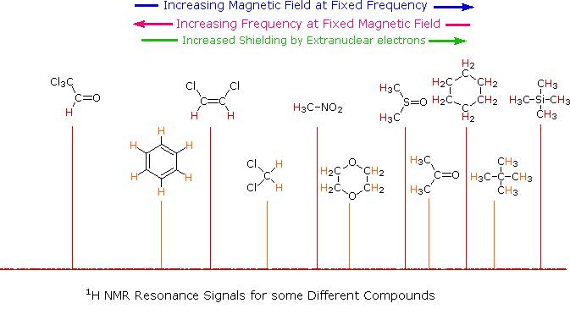
Shielding = Upfield
The nucleus feels weaker magnetic field. A nucleus whose chemical shift has been decreased due to addition of electron density, magnetic induction, or other effects.”
Deshielding = Downfield
The nucleus feels stronger magnetic field. A nucleus whose chemical shift has been increased due to removal of electron density, magnetic induction, or other effects.

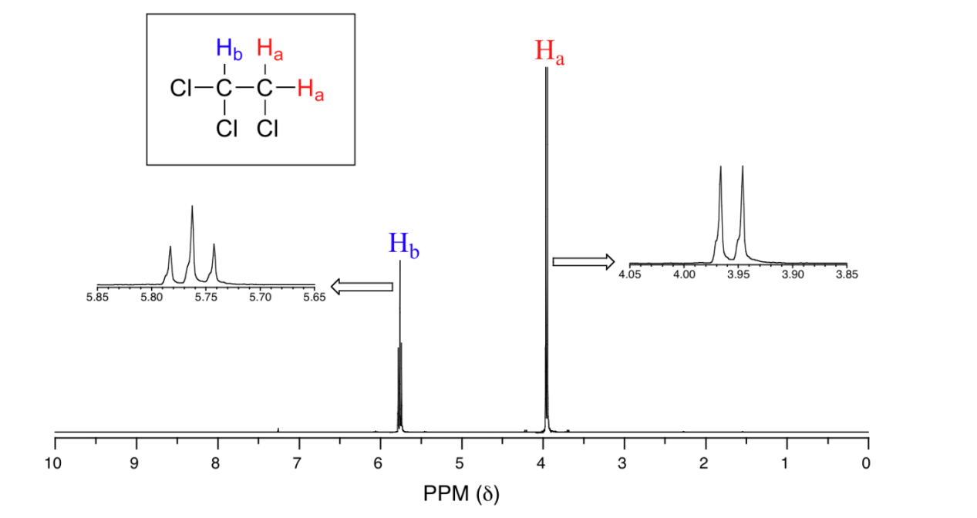
spin-spin coupling- the magnetic interactions between neighboring, non-equivalent NMR-active nuclei
n + 1 rule: if a set of hydrogens has n neighboring, non-equivalent hydrogens, it will be split into n + 1 subpeaks
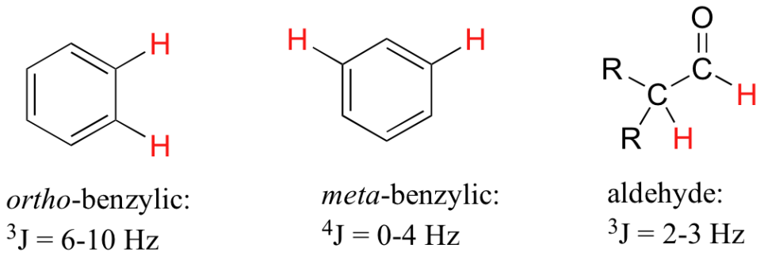
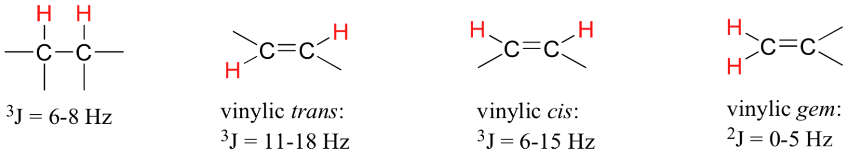
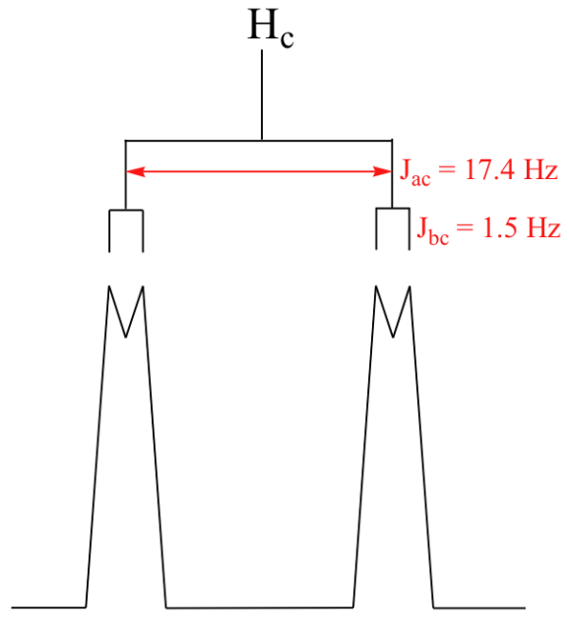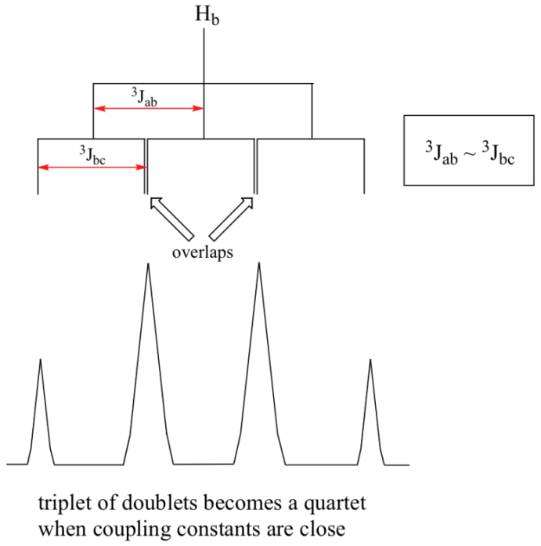
When a proton is coupled to two different protons, then the coupling constants are likely to be different, and instead of a triplet, a doublet of doublets will be seen.
If a proton is coupled to two other protons of one type, and a third of another type with a different, smaller coupling constant, then a triplet of doublets is seen.
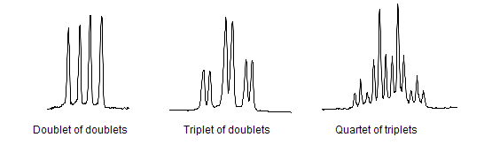
By convention the pattern created by the largest coupling constant is indicated first and the splitting patterns of smaller constants are named in turn. In the case below it would be erroneous to refer to the quartet of triplets as a triplet of quartets.
Homotopic, enantiotopic, diastereotopic
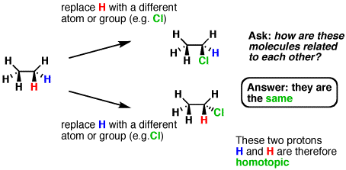
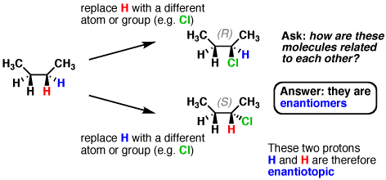
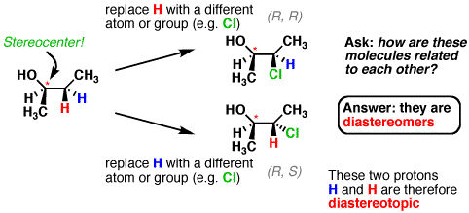
- homotopic protons have the exact same chemical shift
- enantiotopic protons have the same chemical shift in the vast majority of situations. However, if they are placed in a chiral environment (e.g. a chiral solvent) they will have different chemical shifts.
- diastereotopic protons have different chemical shifts in all situations
D₂O Shake
Labile protons, OH, NH₂, SH, have no characteristic chemical shift, but they cause a downfield shift of approximately 2-4 ppm for H atoms on C_{α} (carbon directly bonded to OH, NH2, SH), and of less than 1-2 ppm for H atoms on C_{β} (bonded to C_{α}). To avoid this, or to suppress any acidic proton, we can shake the solution with D₂O, and the peak will disappear because the H atoms have been replaced by D atoms. The nonacidic H atoms, such as those bonded to carbon atoms, will not be affected by D₂O.

C¹³ NMR
Like proton NMR, each peak corresponds to a type of carbon in a different environment.
There is no C¹³-C¹³ coupling, because the abundance of C13 is less than 1%. In other words, there are usually no two C¹³ atoms right next to each other in a molecule.

Isolation of trimyristin from nutmeg
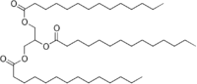
Activated carbon has a large non-polar surface that attracts large molecules through induced dipole-induced dipole and dipole-induced dipole interactions. Because trimyristin is a large non-polar molecule, the amount of activated carbon used to decolorize the solution should be minimized to avoid loss of the trimyristin by adsorption onto the surface of the activated carbon.
Black particles dispersed throughout the crystal are activated carbon.
Trimyristin is soluble in acetone, so it is not a good idea to wash the crystal with acetone that is not ice cold. Before determining the melting point, the acetone has to be dried

Hydrogenation
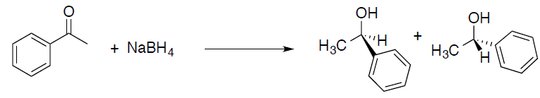 Both enantiomers equally abundant.

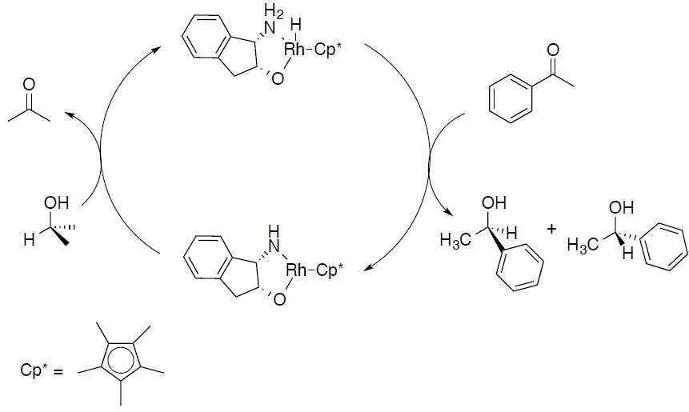 Not equally abundant.
If we used less catalyst, the reaction would be slower.
NMR would not be a useful method because to quantify the amount of each enantiomer because the chemical shifts of enantiomeric H are the same. However, it would be able to tell diastereomers apart.
-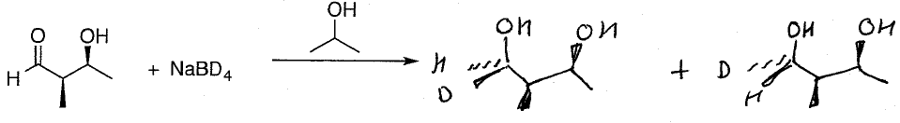
If we didn’t have access to chiral GC or chiral HPLC, we could react the enantiomers with other chiral molecules, which would form two different diastereomers, which are different by NMR. We could also shine line through it and see the polarization effect.

Nucleophilic substitution
- Primary carbon, mainly SN2; tertiary carbon mainly SN1 and E1 (but not considered).
- NaI in acetone
  - I- is the nucleophile, Cl and Br are leaving groups. Acetone is a polar aprotic solvent, good for SN2 reactions.
  - NaBr and NaCl are not soluble in acetone, so observe precipitation to indicate reaction occurring.
- AgNO3 in ethanol
  - Ag+ binds to R-Cl and R-Br to make R-AgCl and R-AgBr, which are good leaving groups. Leaving group leaves and SN1/E1 occurs. AgCl and AgBr are not soluble in ethanol.
- It is important to use dry tubes for the reactions involving sodium iodide in acetone, because sodium chloride and bromide are very soluble in water. If there is too much water present, these products do not precipitate and it is not possible to evaluate the relative rates of reaction.
- The reaction of 1-bromopropane with sodium iodide to give 1-iodopropane is endothermic. To obtain a good yield of product from this reaction, one either needs to use an excess of one of the starting materials or to remove one of the products as it is formed. If acetone is used as the solvent for this reaction, the sodium bromide that is formed precipitates from the reaction, effectively removing one of the products and driving the reaction to completion.
- 2-bromopropane reacts much faster than bromocyclopropane, because the transition state is much more stable in the first case than in the second case, which has a high angle strain (with a 60 degree angle at sp3)

Alpha-pinene and alpha-pinene oxide
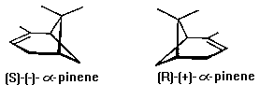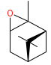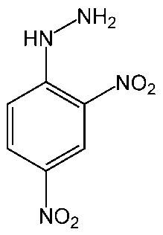
Alpha-pinene oxide DNPH
- We developed the TLC plate, then we dipped the plate in dinitrophenylhydrazine (DNPH)
- We observed the decomposition of alpha-pinene oxide on the silica plate, because silica gel is slightly acidic and can cause epoxide to be protonated.
- To avoid this we can rinse the silica gel with a base, put some base in the running solvent (in TLC), or change the stationary phase (silica gel) to something that’s not acidic

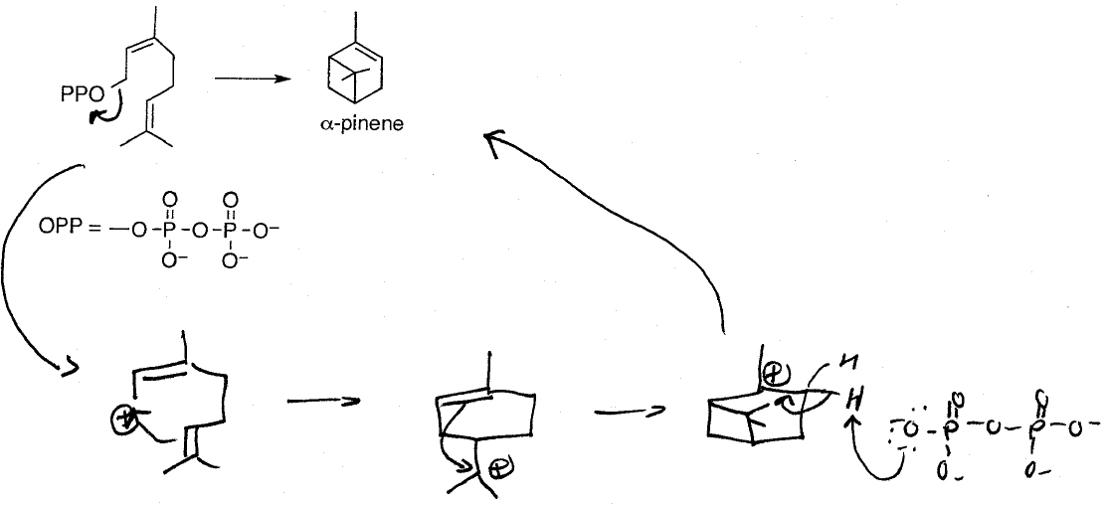

Grignard
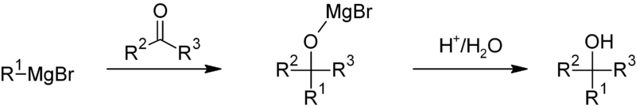
- Dry glassware is essential for this reaction to happen, because magnesium is very reactive in water.
- To increase yield, crush the magnesium powder to remove the magnesium oxide layer
- It is not a good idea to rinse the glassware with acetone before reaction, because:
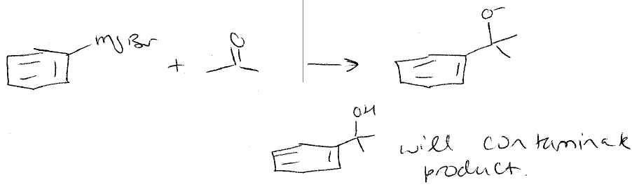
- Grignard reagents are strong bases and can deprotonate any aldehyde or ketone with an acidic H.

