Chemistry 112A Second Midterm Review Sheet
Summary of reactions
Antimarkovnikov

Markovnikov
HOMO is pi bonding
LUMO is empty p
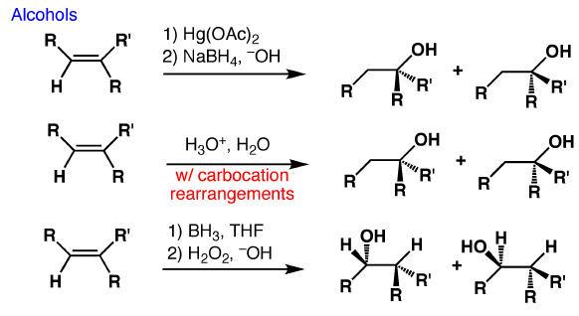 | Markovnikov  Markovnikov  Antimarkovnikov
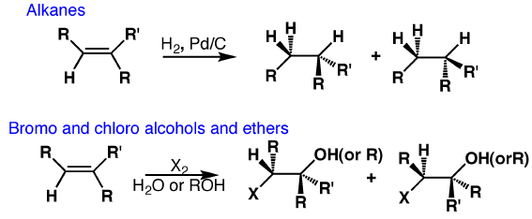Antimarkovnikov
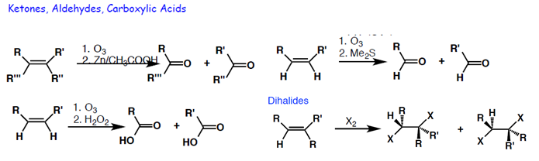

Mechanisms
Hydrobromination – Markovnikov (without peroxide)
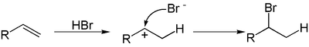
HOMO is the pi bond on alkene, LUMO is the p orbital on Br

Hydrobromination – anti-Markovnikov (with peroxide)
Chain initiation
Chain propagation
Chain termination
Only hydrogen bromide would work because
The hydrogen-fluorine bond is so strong that fluorine radicals aren't formed in the initiation step.
With hydrogen chloride, the second half of the propagation stage is very slow. If you do a bond enthalpy sum, you will find that the following reaction is endothermic.
This is due to the relatively high hydrogen-chlorine bond strength.
Hydrogen iodide
In this case, the first step of the propagation stage turns out to be endothermic and this slows the reaction down. Not enough energy is released when the weak carbon-iodine bond is formed.
Oxymercuration
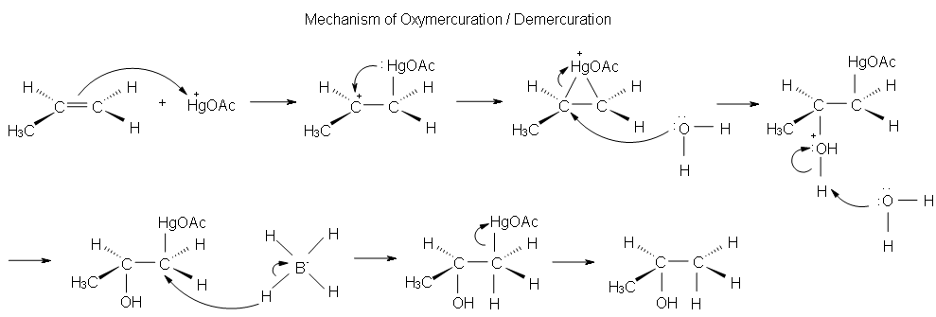
Hydroboration-oxidation
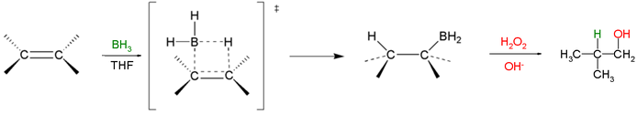
HOMO is the pi bond, LUMO is the p orbital on B

Halogenation
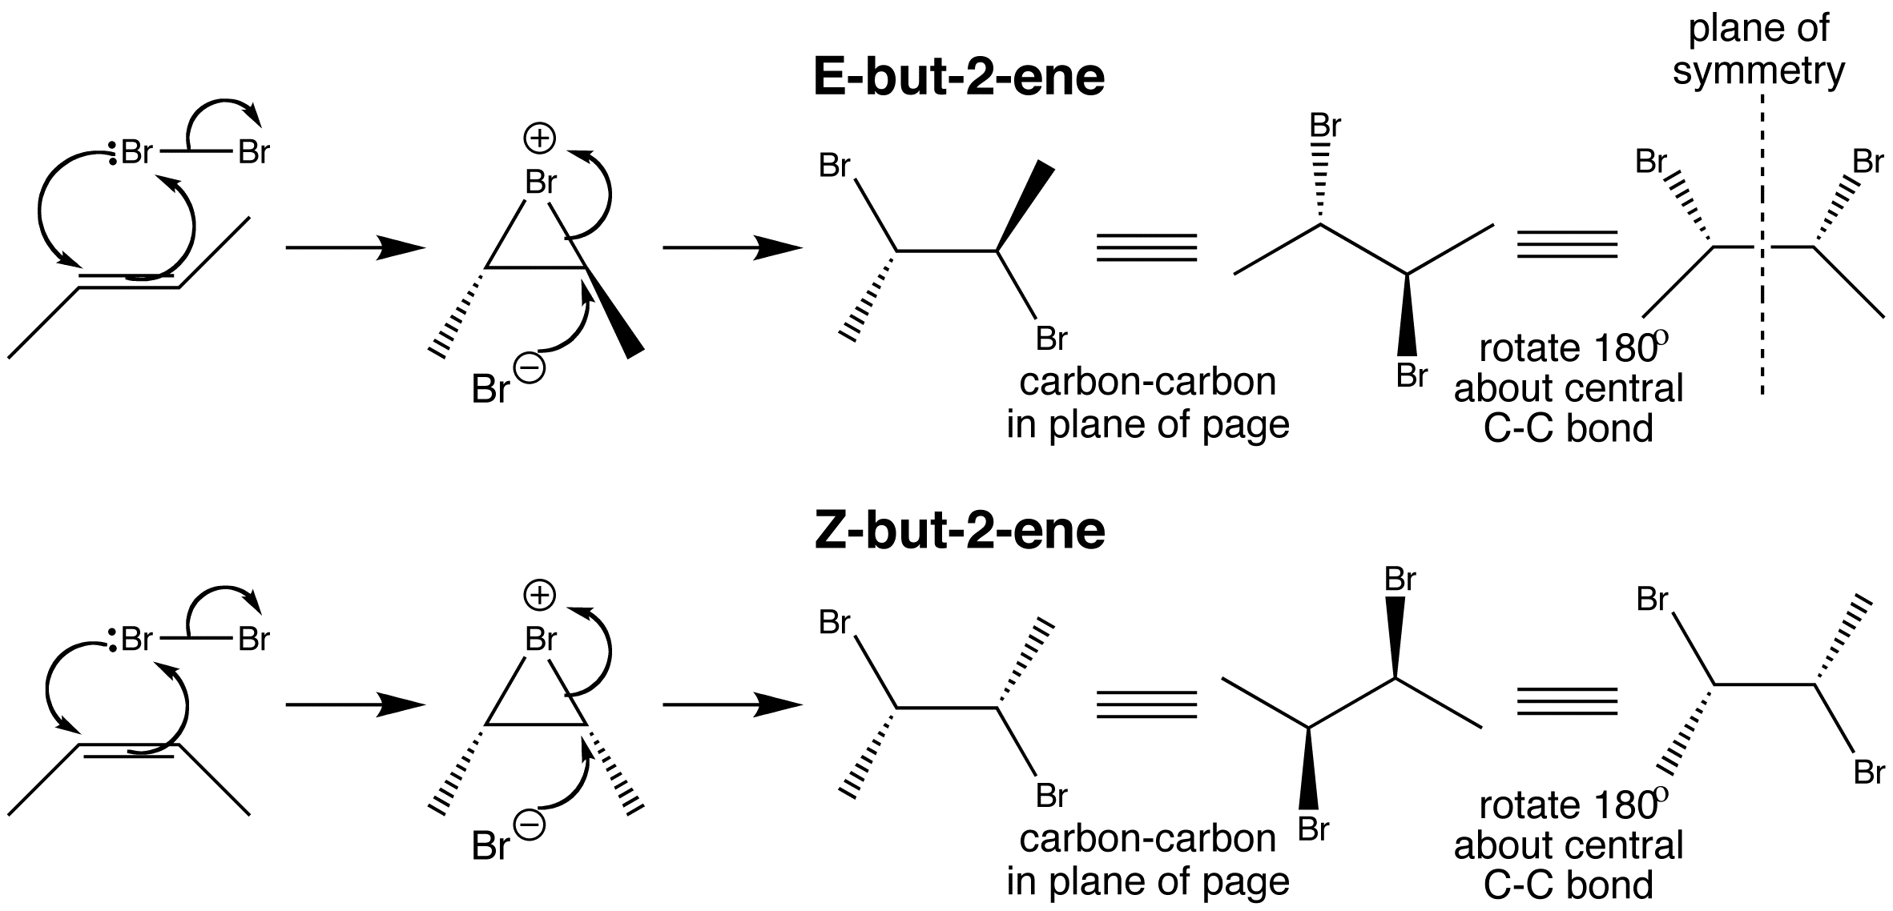
HOMO is the pi on alkene, HOMO is the lone pair on Br-
LUMO is the sigma antibonding on Br-Br LUMO is the sigma antibonding on C-Br

Ozonolysis
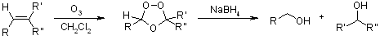
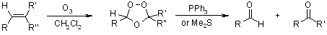
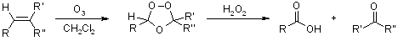
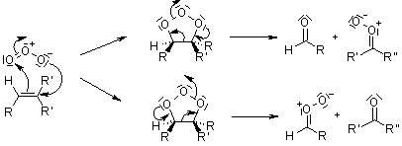
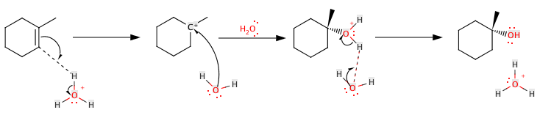
Hydration of alkenes into alcohol
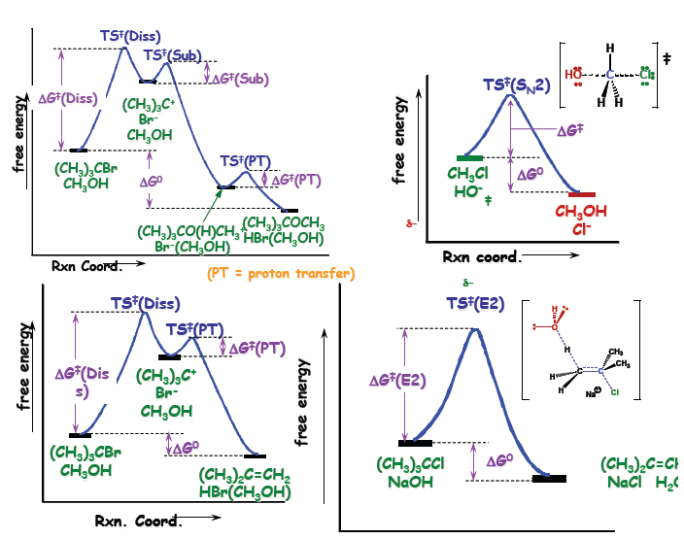
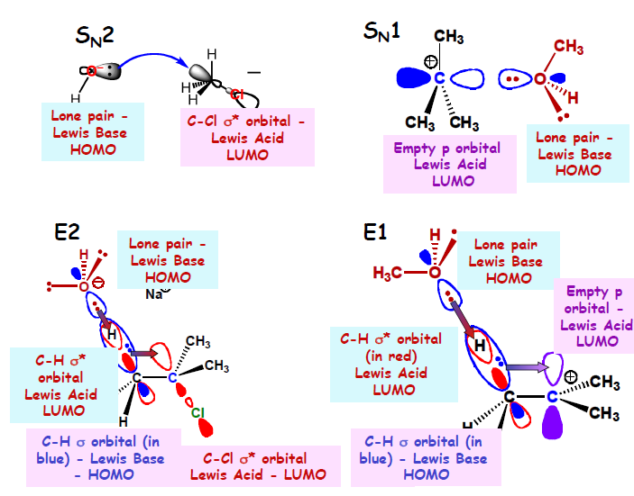
 | Type of Nu / Base
Haloalkane | Poor Nu (e.g. H2O) | Weak Base, Good Nu (e.g. I-) | Strong base unhindered Nu  (e.g. CH3O-) | Strong base, hindered Nu (e.g. (CH3)3CO-)
Methyl | NR | SN2 | SN2 | SN2
1 unhindered | NR | SN2 | SN2 | E2
1 branched | NR | SN2 | E2 | E2
Secondary | Slow SN1, E1 | SN2 | E2 | E2
Tertiary | SN1, E1 | SN1, E1 | E2 | E2

 | SN2 Reactions | SN1 Reactions | E2 Reactions | E1 Reactions
Mechanism | Stereospecific - proceeds with inversion of configuration  No intermediates - sp2 hybridized transition state. | Not Stereospecific  Carbocation intermediate – carbocation rearrangements occur  Unimolecular. | Stereospecific - proceeds fastest from anti orientation of leaving group and hydrogen being deprotonated.  No intermediates | Not Stereospecific  Carbocation intermediate – carbocation rearrangements occur  Unimolecular.
Substrate | Large groups slow down SN2 due to steric hindrance. 3° carbon centers do not react by SN2. Neopentyl halides do not react by SN2.  Reactive carbon center must be able to attain sp2 hybridization in transition state | More substituted carbon centers react faster because carbocation intermediate is more stable, which stabilizes T.S.  Reactive carbon center must be able to attain sp2 hybridization in transition state | Not sensitive to substitution at carbon center.  Anti conformation between leaving group and proton should be achievable. | More substituted carbon centers react faster because carbocation intermediate is more stable, which stabilizes T.S.  Reactive carbon center must be able to attain sp2 hybridization in transition state
Leaving Group | Weak bases are better leaving groups. Conjugate acids of good leaving groups have pKa<0 | Weak bases are better leaving groups. Conjugate acids of good leaving groups have pKa<0 | Weak bases are better leaving groups. Conjugate acids of good leaving groups have pKa<0 | Weak bases are better leaving groups. Conjugate acids of good leaving groups have pKa<0
Nucleophile | Polarizability, size, and basicity contribute to nucleophilicity.  The trend in nucleophilicity of the halides is different in polar protic and polar aprotic solvents. | Rate does not depend on nucleophile. | Strong base is required. | Rate does not depend on nucleophile.
Solvent | SN2 reactions with anionic (negatively charged) nucleophiles are faster in polar aprotic solvents. | Faster in in polar protic solvents | E2 reactions with anionic (negatively charged) bases are faster in polar aprotic solvents. | Faster in in polar protic solvents.

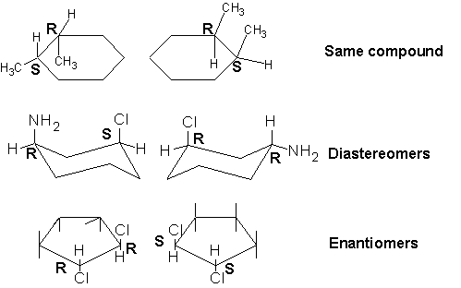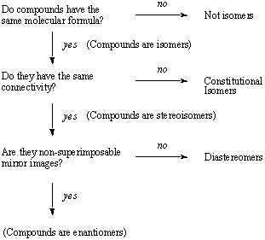

R&S
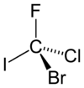 | The hypothetical molecule bromochlorofluoroiodomethane shown in its R-configuration would be a very simple chiral compound. The priorities are assigned based on atomic number (Z): iodine (Z = 53) > bromine (Z = 35) > chlorine (Z = 17) > fluorine (Z = 9). Allowing fluorine (lowest priority) to point away from the viewer the rotation is clockwise hence the R-assignment.
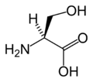 | In the assignment of L-serine highest priority is given to the nitrogen atom (Z = 7) in the amino group (NH₂). Both the methylalcohol group (CH₂OH ) and the carboxylic acid group (COOH) have carbon atoms (Z = 6) but priority is given to the latter because the carbon atom in the COOH group is connected to a second oxygen (Z=8) whereas in the CH₂OH group carbon is connected to a hydrogen atom (Z=1). Lowest priority is given to the hydrogen atom and as this atom points away from the viewer the counterclockwise decrease in priority over the three remaining substituents completes the assignment as S.
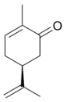 | The stereocenter in S-carvone is connected to one hydrogen atom (not shown, priority 4) and three carbon atoms. The isopropene group has priority 1 (carbon atoms only) and for the two remaining carbon atoms priority is decided with the carbon atoms two bonds removed from the stereocenter, one part of the keto group (O,O,C priority 2) and one part of an alkene (H,C,C priority 3). The resulting counterclockwise rotation results in a S.

Meso compound should have 2 or more stereocenters, an internal plane, and the stereochemistry should be R S.
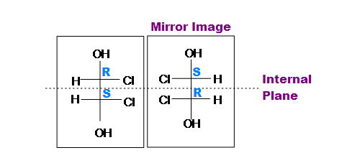
Optical purity = % enantiomeric excess = % enantiomer₁ - % enantiomer₂ = 100 [α]_{mixture} / [α]_{pure sample}
ee% = 100 ([major enantiomer] - [minor enantiomer]) / ([major enantiomer] + [minor enantiomer])
A chiral compound has a specific rotation that is equal in magnitude but opposite in direction from its enantiomer.
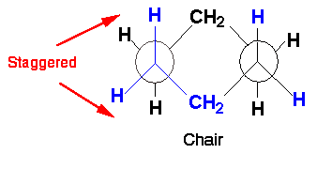  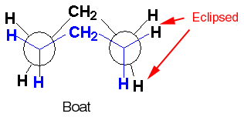 | 