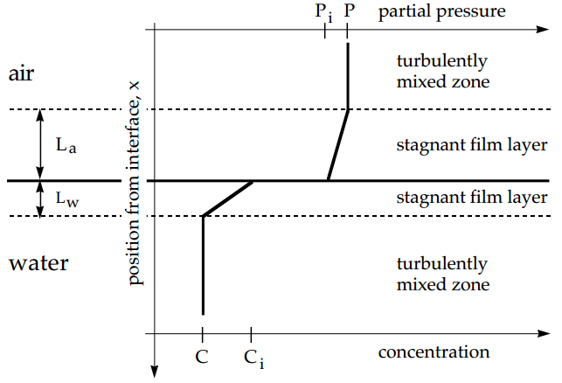 |  | $$J_{b}=k_{m}\left(C-C_{i}\right)=\frac{D\left(C-C_{i}\right)}{L_{f}} k_{m}=\frac{D}{L_{f}} J_{gl}=D_{w}\frac{C_{i}-C}{L_{w}}=D_{a}\frac{(P-P_{i})/RT}{L_{a}}=k_{gl}(C_{s}-C)$$  C = bulk Cs = equilibrium with bulk$=K_{H}P$ Ci = interface$=K_{H}P_{i}$  $$D_{w}\frac{C_{i}-C}{L_{w}}=D_{a}\frac{(C_{s}-C_{i})}{RTK_{H}L_{a}}=k_{gl}\left(C_{s}-C\right) k_{gl}=\frac{D_{w}}{L_{w}}\left(\frac{D_{a}L_{w}}{D_{w}L_{a}RTK_{H}+D_{a}L_{w}}\right)=\frac{1}{\frac{L_{w}}{D_{w}}+\frac{L_{a}}{D_{a}}RTK_{H}}$$  $$\frac{1}{k_{gl}}=\frac{1}{k_{l}}+\frac{RTK_{H}}{k_{g}} k_{l}=\frac{D_{w}}{L_{w}} k_{g}=\frac{D_{a}}{L_{a}}$$  If $k_{l}<\frac{k_{g}}{RTK_{H}}$ liquid film resistance dominates If $k_{l}>\frac{k_{g}}{RTK_{H}}$ gas film resistance dominates
Batch reactor $\frac{d\left(CV\right)}{dt}=rV$ | Zeroth order  $$C\left(t\right)=C\left(0\right)-k_{o}t until C runs out τ=\frac{C\left(0\right)}{k_{0}}$$ |  | First order  $$C\left(t\right)=C\left(0\right)e^{-k_{1}t} τ=\frac{1}{k_{1}}$$ | Second order  $$C\left(t\right)=\frac{C\left(0\right)}{1+2k_{2}C(0)t} τ=\frac{1}{2k_{2}C(0)}$$
CMFR  $$\frac{d\left(CV\right)}{dt}=QC_{in}-QC+rV$$  $$\frac{dC}{dt}=\frac{1}{τ}\left(C_{in}-C\right)+r$$ | Zeroth order  $$\frac{dC}{dt}=\frac{1}{τ}\left(C_{in}-C\right)-k_{o}$$  $$C=C_{in}-k_{o}τ$$ |  | First order  $$\frac{dC}{dt}=\frac{1}{τ}\left(C_{in}-C\right)-k_{1}C$$  $$C=\frac{C_{in}}{1+k_{1}τ}$$ | Second order  $$\frac{dC}{dt}=\frac{1}{τ}\left(C_{in}-C\right)-2k_{2}C^{2}V$$  $$C=\frac{{\left(8k_{2}C_{in}τ+1\right)}^{0.5}-1}{4k_{2}τ}$$
PFR $U\frac{dC(x)}{dx}=r$ | Zeroth order $C(x)=C(0)-\frac{k_{o}x}{U}$ |  | First order$C(x)=C\left(0\right)e^{-\frac{k_{1}}{U}x}$ | Second order $C(x)=\frac{UC\left(0\right)}{U+2k_{2}C\left(0\right)x}$
Ci, Q into CMFR C1, Q into PFR C2,Q (both first order) $C_{1}=\frac{C_{i}}{1+kτ_{CMFR}} C_{2}=C_{1}e^{-kτ_{PFR}} C2=\frac{C_{i}}{1+kτ_{CMFR}}e^{-kτ_{PFR}}$
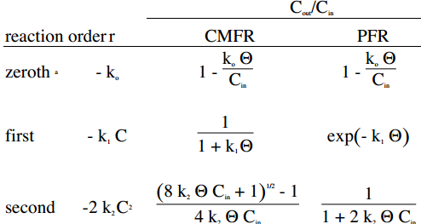 | $$τ_{r}=\frac{V}{Q\left(1+R\right)}=\frac{τ}{1+R} R is recycle ratio$$  $$C_{in}Q+C_{out}RQ-C_{in}^{*}\left(Q+RQ\right)=0 C_{in}^{*}=\frac{C_{in}+RC_{out}}{1+R}$$  $$C_{out}=\frac{C_{in}+RC_{out}}{1+R}e^{-\frac{kτ}{1+R}}=\frac{e^{-\frac{kτ}{1+R}}}{1+R[1-e^{-\frac{kτ}{1+R}}]}$$
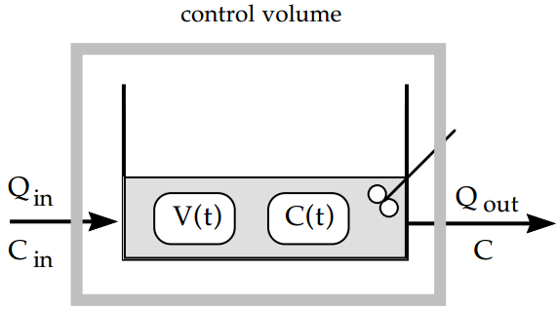 | $$\frac{d\left(CV\right)}{dt}=C\frac{dV}{dt}+V\frac{dC}{dt}=Q_{in}C_{in}-Q_{out}C-kVC V\left(t\right)=V_{0}+\left(Q_{in}-Q_{out}\right)t$$  $$C\left(Q_{in}-Q_{out}\right)+\left(V_{0}+\left(Q_{in}-Q_{out}\right)t\right)\frac{dC}{dt}=Q_{in}C_{in}-Q_{out}C-k\left[V_{0}+\left(Q_{in}-Q_{out}\right)t\right]C$$  $$\frac{dC}{dt}=\frac{Q_{in}\left(C_{in}-C\right)}{\left(Q_{in}-Q_{out}\right)t+V_{0}}-kC$$
Dispersion is concentrations spread out in space. Diffusivity: big↓, small↑, water ↓, air ↑, low T ↓, high T ↑ $x=\sqrt{2Dt} {Re}_{p}=\frac{d_{p}V_{∞}}{v \left(kinematic viscosity\right)}=\frac{d_{p}V_{∞}ρ_{f}}{μ (dynamic viscosity)}$
Molecular diffusion: $J=-D\frac{dC}{dx}$ D [=] m²/s | Turbulent diffusion: $J=-ε\frac{dC}{dx}$ $ε$[=] m²/s | Advection:$J \left[\frac{mol}{m^{2}s}\right]=u\left[\frac{m}{s}\right]C [\frac{mol}{m^{3}}]$
Adsorption- surface uptake Absorption- distributed uptake Sorption- either one or both $linear:q_{e}=K_{ads}C_{e} Langmuir: q_{e}=q_{max}\frac{bC_{e}}{1+bC_{e}} Freundlich: q_{e}=K_{f}C_{e}^{\frac{1}{n}}$
$${water dissociation: K}_{w}=\left[H^{+}\right]\left[OH^{-}\right]$$  $$material balance on A: C_{total}=\left[A^{-}\right]+[HA]$$  $${acid dissociation: K}_{A}=\frac{\left[H^{+}\right]\left[A^{-}\right]}{[HA]}=\frac{\left[H^{+}\right]\left[A^{-}\right]}{C_{total}-\left[A^{-}\right]}$$ | $$K_{A}C_{total}-K_{A}\left[A^{-}\right]=\left[H^{+}\right]\left[A^{-}\right] \left[A^{-}\right]=\frac{K_{A}C_{total}}{K_{A}+\left[H^{+}\right]}$$  $$electroneutrality: \left[H^{+}\right]=\frac{K_{w}}{\left[H^{+}\right]}+\frac{C_{total}K_{A}}{K_{A}+\left[H^{+}\right]}$$
Dissolution of ammonium chloride involving a phase change: $electroneutrality: \left[H^{+}\right]+\left[{NH}_{4}^{+}\right]=\left[{OH}^{-}\right]+\left[{Cl}^{-}\right] {water dissociation: K}_{w}=\left[H^{+}\right]\left[OH^{-}\right]$
$$Henry^{'}s law:\left[NH_{3}\left(aq\right)\right]=K_{H}P_{NH_{3}} {acid dissociation: K}_{A}=\frac{\left[NH_{3}\left(aq\right)\right]\left[H^{+}\right]}{\left[NH_{4}^{+}\right]} MB on {NH}_{3}:n_{NH_{3}}=\left(\left[NH_{4}^{+}\right]+\left[NH_{3}\left(aq\right)\right]\right)V_{w}+\frac{P_{NH_{3}}V_{air}}{RT} MB on Cl: n_{Cl}=n_{NH_{3}}$$
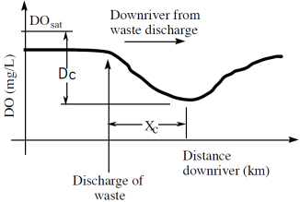 | $$\frac{d\left[BOD\right]}{dt}=-k_{BOD}\left[BOD\right] \left[BOD\right]\left(t\right)=\left[BOD\right]\left(0\right)*e^{-k_{BOD}t} \frac{d\left[DO\right]}{dt}=-k_{BOD}\left[BOD\right] \left[DO\right]\left(t\right)=\left[DO\right]\left(0\right)-\left[BOD\right]\left(0\right)*\left(1-e^{-k_{BOD}t}\right)$$  Dc critical oxygen deficit or min DO concentration. xc critical distance or distance downstream at which Dc occurs.  $$J_{gl}=k_{gl}\left({DO}_{s}-DO\right) {UADO}_{x}-UADO_{x+∆x}+J_{gl}W∆x+r_{O_{2}}A∆x=0 U\frac{d\left(DO\right)}{dx}=J_{gl}\frac{W}{A}+r_{O_{2}} DO\left(0\right)=\frac{DO_{r}Q_{r}+DO_{w}Q_{w}}{Q_{r}+Q_{w}}$$
$$r_{O_{2}}=-k_{1}BOD\left(0\right)e^{-\frac{k_{1}x}{U}} U\frac{d\left(DO\right)}{dx}=k_{gl}\frac{W}{A}\left(DO_{s}-DO\right)-k_{1}BOD\left(0\right)e^{-\frac{k_{1}x}{U}} D={DO}_{s}-DO(0) k_{2}=k_{gl}\frac{W}{A} U \frac{dD}{dx}=-k_{2}D+k_{1}BOD\left(0\right)e^{-\frac{k_{1}x}{U}}$$
$$D=\frac{k_{1}BOD\left(0\right)}{k_{2}-k_{1}}\left(e^{-\frac{k_{1}x}{U}}-e^{-\frac{k_{2}x}{U}}\right)+D_{0}e^{-\frac{k_{2}x}{U}} D_{C}=\frac{k_{1}}{k_{2}}BOD\left(0\right)e^{-\frac{k_{1}x_{C}}{U}} x_{c}=\frac{U}{k_{2}-k_{1}}\ln{[\frac{k_{2}}{k_{1}}}(1-\frac{D_{0}\left(k_{2}-k_{1}\right)}{BOD(0) })]$$
DO_{min} content of water to support higher life: 2 mg/L abs lower limit, 4 mg/L game fish maintain Dc (DO_{sat}-DO) small so that DO>DO_{min}
To reduce Dc- biological treatment (reduce $BOD(0)$ in waste) increase flow of BOD-free water increase river aeration- k₂
oligotrophic - low nutrients, low productivity mesotrophic - intermediate nutrients and productivity eutrophic - high nutrients, high productivity
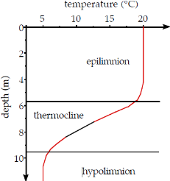 | epilimnion - warm surface layer thermocline - ΔT zone hypolimnion - cool, lower layer  Summer - stable stratification: warm water (lower density) on top, cool water (higher density) on bottom, little mixing between upper and lower layer  Autumn turnover- epilimnion cools, reduced solar heating, lower air temperature, cooling surface water sinks to thermocline, if epilimnion cools to hypolimnion temperature complete mixing of lake Winter stratification- surface water freezes, slow heat transfer through lake by conduction  Stably stratified- coupled CMFR unstratrified- single CMFR Eutrophication promotes excessive growth of algae and phytoplankton  Ground water- unsaturated zone (vadose zone) air-filled porous media saturated zone (aquifer) water-filled porous media
Hazardous water landfills and sanitary landfills are two major sources of GW contamination. An estuary is where a river meets the ocean and the resulting water body is affected by the tidal action of a sea. All of the water that falls on land and runs off into the oceans passes through estuaries. Mixing influenced by T and salinity.
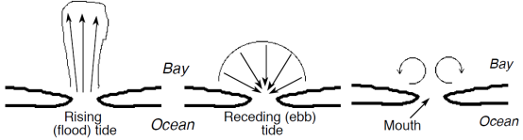 | River tends to flow onto the water contained in an estuary, leading to a stable stratification. Oscillating tidal flow disrupts the stratification by pushing salt water into the river’s mouth. Issues of concern: saltwater intrusion, municipal sewage discharge, toxic materials from industry, runoff with storm water.  Ocean outfall- Municipal sewage of coastal cities is discharged to oceans.
WW treatment- physical, chemical, biological. Primary- application of physical and/or chemical. Secondary- BOD removal. Advanced
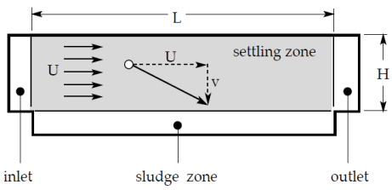 | Settling distance during transit = vL/U = H’ fraction removed $= \frac{H’}{H}=\frac{v}{v_{c}} v_{c}=\frac{HU}{L}=\frac{Q}{A_{s}}=\frac{Q}{LW} v is settling velocity$  $${Re}_{p}<0.3$$ $$C_{d}=\frac{24}{{Re}_{p}} F_{d}=3πμd_{p}V_{∞} v_{t}=\frac{gd_{p}^{2}}{18}\left(\frac{ρ-ρ_{f}}{μ}\right)$$  0.3~1000 $$C_{d}=\frac{24}{{Re}_{p}}\left(1+0.14{Re}_{p}^{0.7}\right) v_{t}={\left[\frac{4}{3}\frac{gd_{p}}{C_{d}}\left(\frac{ρ-ρ_{f}}{ρ_{f}}\right)\right]}^{\frac{1}{2}} ρ>ρ_{f} v_{t}={\left[\frac{4}{3}\frac{gd_{p}}{C_{d}}\left(\frac{ρ_{f}-ρ}{ρ_{f}}\right)\right]}^{\frac{1}{2}} ρ_{f}>ρ$$  1000~35000 $$C_{d}=0.445 F_{d}=0.173ρ_{f}d_{p}^{2}V_{∞}^{2} v_{t}={\left[\frac{4}{3}\frac{gd_{p}}{C_{d}}\left(\frac{ρ_{f}-ρ}{ρ_{f}}\right)\right]}^{\frac{1}{2}}$$
$$Darcy’s law- Q = KA\frac{Δh}{L} U=-K\frac{dh}{dl}\left(=\frac{-Δh}{L}\right) K=\frac{kρ_{f}g}{μ_{f}} K is hydraulic conductivity \left(\frac{m}{s}\right) k is intrinsic conductivity \left({cm}^{2}\right) 1 darcy=0.987*{10}^{-12 }m^{2}$$
$$U=-\frac{kρ_{w}g}{μ_{w}}\frac{dh }{dl} ∅=posority=\frac{pore volume}{total volume} k=\frac{∅^{3}d^{2}}{180{\left(1-∅\right)}^{2}} d=diameter \frac{h}{L}=\frac{5μ}{gρ_{f}}\frac{{\left(1-∅\right)}^{2}}{∅^{3}}S^{2}\frac{Q}{A_{x}} S is surface area per volume=\frac{6}{φd}$$
$$φ=shape factor=1 for sphere=0.75\sim 0.85 for filter sand d=grain diameter \frac{h}{L}=\frac{5μ}{gρ_{f}}\frac{{\left(1-∅\right)}^{2}}{∅^{3}}{\left(\frac{6}{φd}\right)}^{2}U K=\frac{gρ_{f}}{5μ}\frac{∅^{3}}{{\left(1-∅\right)}^{2}} {\left(\frac{φd}{6}\right)}^{2} k=\frac{1}{5}\frac{∅^{3}}{{\left(1-∅\right)}^{2}} {\left(\frac{φd}{6}\right)}^{2}$$
backwashing- force water upwards through filter bed, lift sand grains, liberate trapped particles, discharge backwash water, or return to head of treatment plant
$$buoyant weight of bed=\left(1-∅_{B}\right)L_{B}A_{x}\left(ρ_{P}-ρ_{w}\right)g=weight of water to expand bed=h_{B}A_{x}ρ_{w}g h_{B}\left(head loss\right)=\frac{L_{B}\left(1-∅_{B}\right)\left(ρ_{P}-ρ_{w}\right)}{ρ_{w}}=\frac{L\left(1-∅\right)\left(ρ_{P}-ρ_{w}\right)}{ρ_{w}}$$
$$∅_{B}={\left(\frac{Q_{B}}{A_{x}v_{t}}\right)}^{0.22} \frac{Q_{B}}{A_{x}} is backwash water velocity. v_{t} is settling velocity A_{x}is cross-sectoinal area$$
Reverse osmosis- force water at high-pressure through fine-pore membrane, desalination of seawater, water softening, wastewater reuse, rejects ionic components
$$J_{w}, water flux across membrane \left(\frac{mass}{area*time}\right)=K_{p}, permeability \left(\frac{time}{length}\right)*\left(P_{a},applied P-π, osmotic P\right)\left(\frac{mass}{length*time^{2}}\right) R=\frac{C_{raw}-C_{treated}}{C_{raw}}$$
Electrodialysis- removal of ions through membranes by transverse electric field, unlike RO, ions cross membranes rather than water, ineffective against nonionic species
Reaction at the cathode: $2e^{-} + 2 H_{2}O → H_{2} (g) + 2 {OH}^{-}$ at the anode: $H_{2}O → 2 H^{+} + .O2 \left(g\right)+ 2e^{-} or 2 {Cl}^{-} → {Cl}_{2} (g) + 2e^{-}$
Disinfection- $\frac{dN}{dt}=-kN \frac{N\left(t_{c}\right)}{N\left(0\right)}=e^{-kt_{c}} (0.01 for 2log removal, 0.001 for 3log removal) Ct_{c}=constant$
on a log log plot, pick a C and the corresponding t_{c}. calculate k based on tc, divide by C to get k’ (a constant). multiply by new C to get new k, calculate tc.
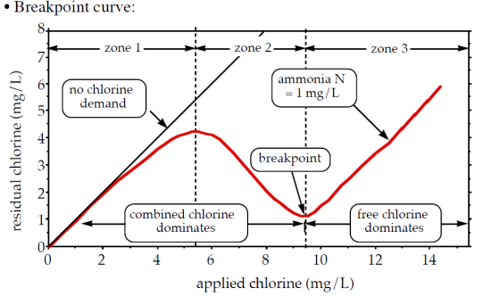 |  | $${Cl}_{2}, {ClO}_{2}, NaOCl, Ca{\left(OCl\right)}_{2} {Cl}_{2}\left(g\right)↔ {Cl}_{2}\left(aq\right) {Cl}_{2}\left(aq\right)+H_{2}O↔HOCl+H^{+}+{Cl}^{-} K_{1}=\frac{\left[HOCl\right]\left[H^{+}\right]\left[{Cl}^{-}\right]}{{Cl}_{2}\left(aq\right)}$$  $HOCl H^{+}+{OCl}^{-} K_{2}=\frac{\left[H^{+}\right]\left[{OCl}^{-}\right]}{\left[HOCl\right]}$HOCl is an oxidant $H_{2}S→{SO}_{4}^{2-} Fe\left(II\right)→Fe\left(III\right)$  Formation of chloramines ${NH}_{3} + HOCl → H_{2}O + {NH}_{2}Cl {NH}_{2}Cl+HOCl→H_{2}O + {NHCl}_{2}$  Ineffective products: ${NHCl}_{2} + HOCl → H_{2}O + {NCl}_{3} || 2 {NHCl}_{2} + HOCl→ N_{2} + H_{2}O + 3 H^{+} + 3 {Cl}^{-}$  ${NH}_{2}Cl + {NHCl}_{2} + HOCl → N_{2}O + 4 H^{+} + 4 {Cl}^{-}$free residual Cl: [HOCl] + [OCl-]  combined available Cl: [NH₂Cl] + [NHCl₂] + [NCl₃] Cl residual: [HOCl] + [OCl-] + [NH₂Cl] + [NHCl₂] + [NCl₃]
 | 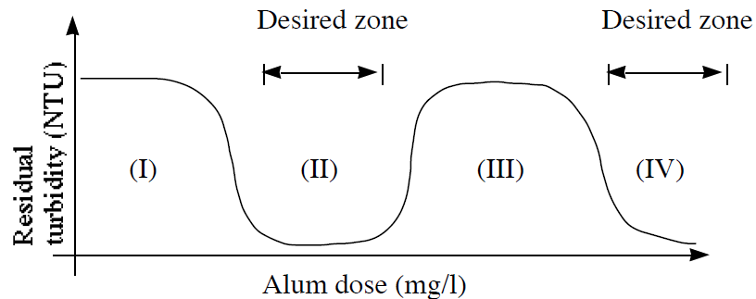 |  |  | Add coagulant mix vigorously (flash mix) to form charged species and precipitates (coagulation), stir gently to increase rate of collision (flocculation), separate solids from water by settling  (I) not enough coagulant ⇒ negatively charged particles  (II) stoichiometric coagulant dose ⇒ neutral particles  (III) too much coagulant ⇒ positively charged particles  (IV) sweep floc ⇒ physical capture of particles by Al(OH)x polymer
 | Electroneutrality, $\sum{z_{i}C_{i}=0}$Ionic strength, $I=\frac{1}{2}\sum{z_{i}^{2}C_{i}}$  Hardness, the sum of the normalities of all multivalent cations. Main cations, ${Ca}^{2+} {Mg}^{2+}$  Compute total harness (TH) compute$Nc = \left[HCO_{3}^{-}\right]+2\left[CO_{3}^{2-}\right]$  If $Nc<TH$ CH = Nc NCH = TH-CH If $Nc>TH$ CH = TH NCH = 0  Convert meq/L hardness to mg/L as CaCO₃ 1meq/L = 50mg/L as CaCO₃  Alk – capacity to neutralize acids $Alk = \left[{OH}^{-}\right]+\left[HCO_{3}^{-}\right]+2\left[CO_{3}^{2-}\right]-[H^{+}]$, meq/L  Lime treatment- ${Ca}^{2+}+2HCO_{3}^{-}+Ca{\left(OH\right)}_{2}→2CaCO_{3}+2H_{2}O$  $${Mg}^{2+}+2HCO_{3}^{-}+2Ca{\left(OH\right)}_{2}→2CaCO_{3}+Mg{\left(OH\right)}_{2}+2H_{2}O$$  To decrease Ca²⁺, increase CO₃²⁻. To decrease Mg ²⁺, increase OH⁻.  Incrase pH, decrease Mg2+, decrease Ca2+ if enough ALK is present (H₂CO₃HCO₃⁻CO₃²⁻)  Na₂CO₃ required Ca(OH)₂ required  $$Alk≥TH, NCH=0$$ None TH + 2 [Mg²⁺] + 2[H₂CO₃*] + 0.00125 eq/L  $$Alk<TH, TH-CH=NCH$$ $$NCH$$ Alk + 2 [Mg²⁺] + 2[H₂CO₃*] + 0.00125 eq/L  If Mg2+ not present, drop Mg2+ and 0.00125. Final step add CO2 to bring pH down to neutral level |  |  |  | 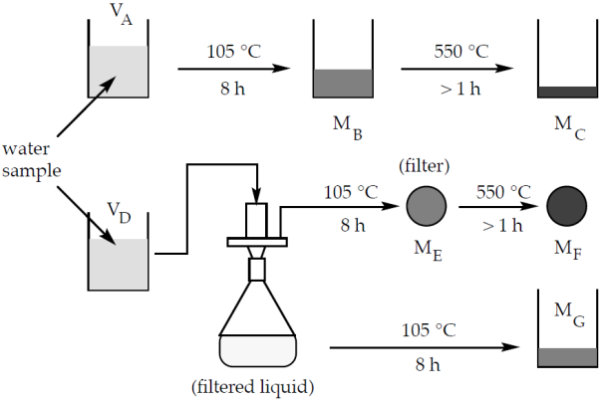  $$TS=\frac{M_{B}}{V_{A}} TDS=\frac{M_{G}}{V_{D}} =TS-SS SS=\frac{M_{E}}{V_{D}}$$  $$TVS=\frac{M_{B}-M_{C}}{V_{A}} VVS=\frac{M_{E}-M_{F}}{V_{D}}$$  Particle concentration – mass (#) particles per fluid volume  Particle density – mass of particle per particle volume
 | 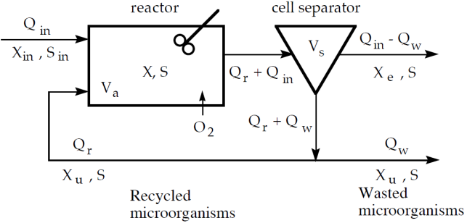 |  | Activated sludge- $BOD + O_{2}+nutrients→cells+{CO}_{2}+H_{2}O$  Separate cells because cells are sources of BOD  Recycle cells to maintain high cell residence time relative to hydraulic residence time ($θ_{c}>θ_{h}$)  Not recycle in order to bleed off dead cells  S- concentration of biodegradable organic matter (BOD) X = concentration of active biomass (VSS)  km- the maximum substrate degradation rate (g BOD / g VSS / d)  Ks- half saturation degradation rate (g BOD/m³) Y- cell-yield coefficient (g VSS / g BOD)
$$\frac{dX}{dt}=μX=r_{g}X \left(growth term\right)-k_{d}X \left(decay term\right) μ=\frac{1}{X}\frac{dX}{dt}=r_{g}-k_{d}=-Y\frac{1}{X}\frac{dS}{dt}-k_{d}=Y\frac{k_{m}S}{K_{s}+S}-k_{d} r_{g}=Y\frac{k_{m}S}{K_{s}+S} \frac{dS}{dt}=-\frac{r_{g}}{Y}X=-\frac{k_{m}S}{K_{s}+S}X$$
$$r_{g}=Y\frac{k_{m}S}{K_{s}+S} K_{s}≫S r_{g}=Y\frac{k_{m}S}{K_{s}} 1st order S≫K_{s} r_{g}=Yk_{m} 0th order$$
$$X_{u}=\frac{Q_{in}+Q_{r}}{Q_{w}+Q_{r}}X assuming X_{e}=0 θ_{c}=\frac{total cell mass}{cell discharge rate}=\frac{V_{A}X}{Q_{w}X_{u}}=\frac{V_{A}}{Q_{w}}\left(\frac{Q_{w}+Q_{r}}{Q_{in}+Q_{r}}\right) =\frac{θ}{W}\left[\frac{R}{1+R}\right] R=\frac{Q_{r}}{Q_{in}} W=\frac{Q_{w}}{Q_{in}}$$
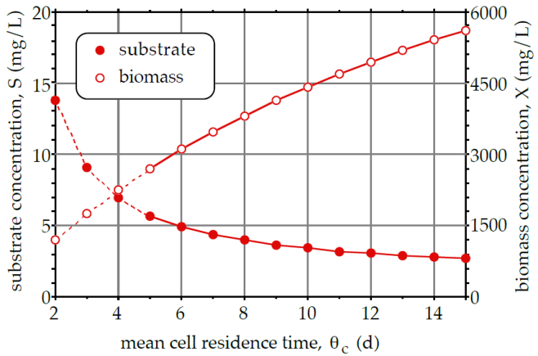 | $$Assume X_{in} = 0, \frac{d\left({XV}_{a}\right)}{dt}=0=X_{u}Q_{r}-X\left(Q_{in}+Q_{r}\right)+V_{a}{\left(\frac{dX}{dt}\right)}_{rxn}$$  $$X\left(Q_{in}+Q_{r}\right)=X_{u}Q_{r}+V_{A}\left(\frac{k_{m}SX}{K_{s}+S}Y-k_{d}X\right)=X\frac{Q_{in}+Q_{r}}{Q_{w}+Q_{r}}+V_{A}\left(\frac{k_{m}SX}{K_{s}+S}Y-k_{d}X\right)$$  $$S=\frac{K_{s}\left(1+k_{d}θ_{c}\right)}{k_{m}Yθ_{c}-\left(1+k_{d}θ_{c}\right)} outlet BOD concentration \left(S\right)is independent of S_{in}$$  $$\frac{d\left({SV}_{a}\right)}{dt}=S_{in}Q_{in}+SQ_{r}-S\left(Q_{in}+Q_{r}\right)+V_{a}{\left(\frac{dS}{dt}\right)}_{rxn}=0$$  $$S\left(Q_{in}+Q_{r}\right)=S_{in}Q_{in}+SQ_{r}+V_{A}\left(-\frac{k_{m}SX}{K_{s}+S}\right) X=\left(\frac{S_{in}-S}{θ}\right)\left(\frac{K_{s}+S}{k_{m}S}\right) θ=\frac{V_{A}}{Q_{in}}$$  $$\frac{k_{m}YS}{K_{S}+S}=\frac{1}{θ_{c}}+k_{d} X=\left(\frac{S_{in}-S}{θ}\right)\left(\frac{Yθ_{c}}{1+θ_{c}k_{d}}\right)$$
OD in reactor- oxidation of BOD to CO₂ and H₂O, conversion of BOD to cell mass if all BOD oxidized, OD=BOD_{in}-BOD_{out}=Q_{in}(S_{in}-S)
Steady-state O2 requirement = $R_{O_{2}}=αQ_{in}\left(S_{in} - S\right)- β Q_{w} X_{u} where α=\frac{BOD_{5}}{BOD_{0}}=1.47 and β=\frac{O_{2} mass}{cell mass} r_{O_{2}}=α\frac{\left(S_{in} - S\right)}{θ}- β\frac{X}{θ_{C}}$
O₃, NO₂, CO, Pb, SO₂, PM – criteria air pollutants
$$PM=\frac{∆M}{Q∆t}=\frac{mg of PM}{m^{3}of air} PM_{10} is with d_{P}≤10 micron PM_{2.5} is with d_{P}≤2.5 micron$$
Fine PM formed by combustion (fires and diesel engines), atm transform (chemical rxn products with low P_{vap} so products condense onto pre-existing PM or form new PM).
Coarse PM formed by evaporation of sea spray (NaCl), wind-blown soil (Si, Ca, Al, Fe), brake wear (metals), fly ash
Primary PM- directly emitted (CO, Pb,SO2, NO2, PM 10, PM 2.5)
Secondary PM- formed in atm ${NH}_{3}\left(g\right)+HNO_{3}\left(g\right)→NH_{4}NO_{3}\left(s\right) 2 NH_{3}\left(g\right)+H_{2}SO_{4}\left(g\right)→{\left(NH_{4}\right)}_{2}SO_{4}(s)$ (O3, NO2, PM2.5)
VOC (combustion + evaporation of fuels + natura l sources) + sunlight secondary organic aerosol (SoA, high MW organic compounds)

