Orders of Growth: running time as input grows
Run time
Types of Orders of Growth from smallest to largest
- Constant
- 46
- 1
- Logarithmic
- log(x)
- log($x^{89}$)
- Linear
- 3x
- 14x -78
- Quadratic
- 3$x^{2}$– 4
- $x^{2}$+ log(x)
- Cubic
- 6$x^{3}$
- 4$x^{3}$–xlog(x)
- Exponential
- 4$x^{5}$+ 5$x^{2}$
- $x^{7}$– 14log(x)

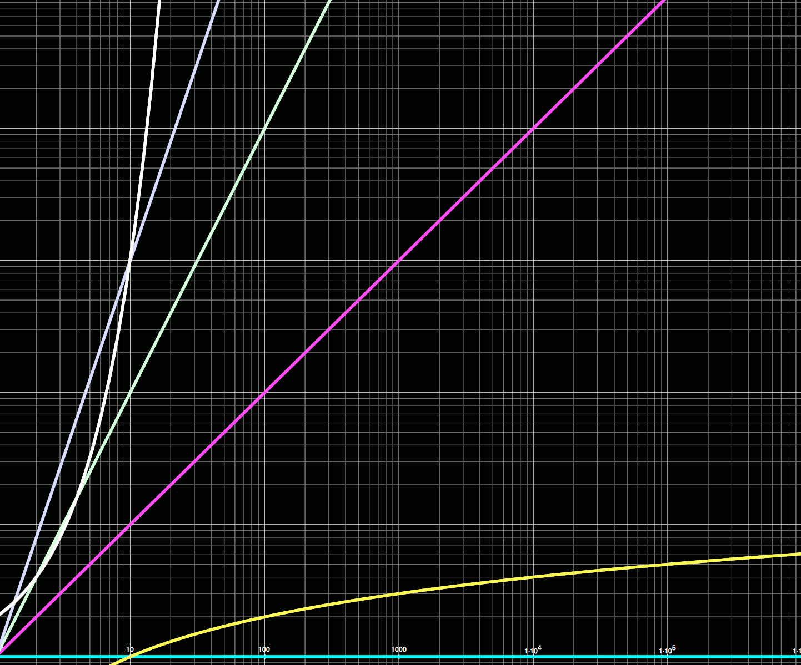
Input size

Big Theta (θ):
-Any function that has a similar growth pattern to the subject function.
Ex: Find Big Theta of:
1. 100 ans: ∈ θ (1)
2. 2xlog(x) ans: ∈ θ (xlogx )
3. 3^n -1 ans; ∈ θ (3^n)
4. 3sqrt(x) + logx ans: ∈ θ (x^(1/2))
a. Whenever you have a polynomial and a log together, ignore the log because the polynomial’s growth rate will always be greater
5. log(x) + log($x^{2}$) ans: ∈ θ (log(x))
a. You can rewrite log($x^{2}$) as 2log(x)

def mystery(L, val, x, y):
if x < y:
return False
z = (x + y) // 2
if L(z) > val:
return mystery(L, val, x, (z – 1))
if L(z) < val:
return mystery(L, val, (z + 1), y
return True

ans: ∈ θ($\log_{2}$n)
-This problem splits up a list(L) in half until it finds a particular value(val) using the beginning and ending items (x and y). So if the length of L was 100, the first call would split it to 50, then 25. 12.5 … etc.

Scheme:
> (+ (* 3 5) (- 10 6) )
19

(if <predicate> <consequent> <alternative>)
Difference between “cond” and “if”:
“if” takes in one predicate and has one consequent and one alternative
(if (= 3 4) 3 6)
6

“cond” can have multiple predicates and consequences, but needs an “else” statement to have an alternative.
(cond ((= 8 9) 4)
((= 9 10) 5)
(else (+ 4 5)))
9

#t means True and #f means False in scheme
> (<= 2 1)
#f

(define (<name> <formal parameters>) <body>)

(lambda (<formal-parameters>) <body>)

“If you did project and understand the scheme part of it, you will be fine on the final”
-GSI that taught this section

Scheme Lists and Parsing:
> (cons 1
(cons 2
(cons 3
(cons 4 nil))))
(1 2 3 4)
> (list 1 2 3 4)
(1 2 3 4)

> (define x (cons 1 2))
> x
(1 . 2)
> (car x)
1
> (cdr x)
2

Parsing: Taking scheme list (1 2 3) and making it into P(1, P(2, P(3, nil)))
.
>’(1. (2. ((4. (3. (2. ()))). ((2. (4. 2)). (3. ())))))
(1 2 (4 3 2)(2 4. 2) 3)

>’(1 2 3. ((4. 5). (5 6. 7)))
(1 2 3 (4. 5) 5 6. 7)

;;deep-map ‘(1 2 (3 4) 5)
(lambda (x) (* x x)))
(1 4 (9 16) 25)
(define (deep-map x f)
(cond ((null? x) ())
((list? (car x))(cons(deep-map (car x) f)(deep-map(cdr x) f)))
(else (cons (f (car x))
(deep-map(cdr x) f)))

Count how many eval and applies there are

(define (f x) (* x x))
(f, (+, 1 (if (= 1 1) 2 1)))

eval:16
apply: 4

Tail Calls:
Tail recursion is just placing your recursive call in the return statement.
Not a tail call:
def f(x):
if x == 0:
return 1
f(x-1)
return 2

Tail call:
π= (4/1) – (4/3) + (4/5) – (4/7)…
(define (calc-pi n)
define (help i sum s)
(if (= i n) sum
(help (+ i 1) (+ sum (* s (/ 4 (+ (* i 2) 1)))) (* s -1))
help (0 0 1))

Map Reduce and Parallelism:
Parallelism:
What are the possible outputs of the following threads run in parallel?
x=0
Thread 1:
- Acquire x
- x = x + 1
- Write x
Thread 2:
1. Acquire x
- x = x + 2
- Write x

Answer: Possible outputs are x= 1, 2, and 3
You can mix and match steps 1 and 2 for both threads, but only 1 write can be computed at a time. For x=1 just run through thread 1 and terminate, x=2 run through thread 2 and terminate, x=3 run through steps 1 and 2 on thread 1 then switch to thread 2 and do steps 1-3 and terminate.

Locks:
Parallel for loop 0<i<10:
acquire_lock(x)
x + = 1 (this line is critical , only 1 thread can do this at a time)
release_lock(x)

Map Reduce: (k,v)= (key,value)
Sort
Map
Reduce

k,v k,v k,v

k,v

k,v
k,v k,v k,v
(emit)
k,v k,v k,v

k,v

The map part of this has a special characteristic called “emit”, where it can choose whether or not to map a function onto the new list. In this way Map Reduce can also be used as a filter.

