Chemical Engineering 141 Notes

H = U + PV
ΔH = ΔU + Δ(PV)

$$C_{V}={\left(\frac{∂U}{∂T}\right)}_{V}$$
$$C_{P}={\left(\frac{∂H}{∂T}\right)}_{P}$$
Mass balance in open system
$\frac{dm}{dt}$ or $\frac{dn}{dt}$ = uAp u is the velocity, A is the area, and u is the mass density or the molar density

Energy balance in open system
$$\frac{{d(mU)}_{CV}}{dt}+ {Δ\left[\left(H+ \frac{1}{2}u^{2}+zg\right)\dot{m}\right]}_{fs}=\dot{Q}+\dot{W}$$
Usually, $\frac{1}{2}u^{2}+zg$ are neglected
$$\frac{{d(mU)}_{CV}}{dt}+Δ{(H\dot{m)} }_{fs}=\dot{Q}+\dot{W}$$
In a closed system where there is no flow stream, $Δ{(H\dot{m)} }_{fs}$ is neglected.
$$\frac{{d\left(mU\right)}_{CV}}{dt}=\dot{Q}+\dot{W}$$
$$ΔU^{t}=Q+W$$
Energy balance on filling up an empty gas tank
$$\frac{{d(mU)}_{tank}}{dt}-H'\dot{m'}=0$$
$$m^{'}=\frac{{dm}_{tank}}{dt}$$
$$\frac{{d\left(mU\right)}_{tank}}{dt}-H^{'\frac{{dm}_{tank}}{dt}}=0$$
$$m_{2}U_{2}-m_{1}U_{1}=H^{'}\left(m_{2}-m_{1}\right)$$
$$U_{2}=H^{'}$$
V = V(T,P)
$$dV={(\frac{∂V}{∂T})}_{P}dT+{(\frac{∂V}{∂P})}_{T}dP$$
$$β= \frac{1}{V}{\left(\frac{∂V}{∂T}\right)}_{P}$$
$$γ= -\frac{1}{V}{\left(\frac{∂V}{∂P}\right)}_{T}$$
$$\frac{dV}{V}= βdT- γdP$$
$$ln\frac{V_{2}}{V_{1}}=β\left(T_{2}-T_{1}\right)+γ(P_{2}-P_{1})$$
$${(\frac{∂P}{∂T})}_{V}=\frac{β}{γ}$$
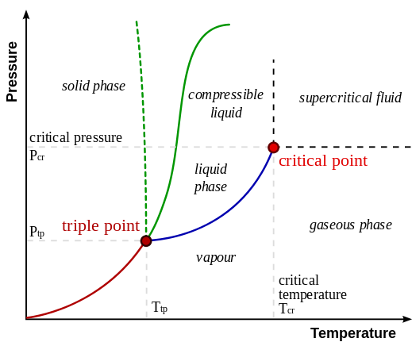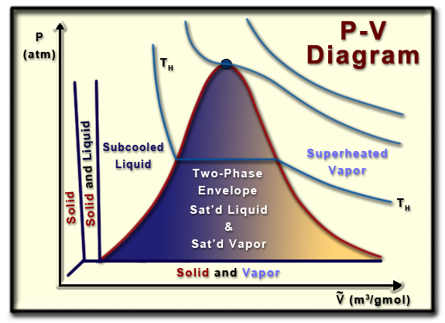
Virial equations of state
$$PV = a + bP + cP^{2}+…$$
if b = aB’, c = aC’
$$PV = a (a+B’P + C’P^{2}+D’P^{3}+…)$$
$$Z =\frac{PV}{RT}$$
$$Z =1+B^{'}P+C^{'}P^{2}+D^{'}P^{3}+…=1+\frac{B}{V}+\frac{C}{V^{2}}+\frac{D}{V^{3}}+…$$
$$γ=\frac{C_{P}}{C_{V}}$$
 | Q | W | U | H
Isothermal | $$RTln\frac{V_{2}}{V_{1}}=-RTln\frac{P_{2}}{P_{1}}$$ | $$-RTln\frac{V_{2}}{V_{1}}=RTln\frac{P_{2}}{P_{1}}$$ | 0 | 0
Isobaric | $$\int{C_{P}dT}$$ | $$-R (T_{2}-T_{1})$$ | $$\int{C_{V}dT}$$ | $$\int{C_{P}dT}$$
Isochoric | $$\int{C_{V}dT}$$ | 0 | $$\int{C_{V}dT}$$ | $$\int{C_{V}dT}$$
Adiabatic | 0 | $\frac{P_{1}V_{1}}{γ-1}{[(\frac{P_{2}}{P_{1}})}^{\frac{γ-1}{γ}}-1]$= $\frac{RT_{1}}{γ-1}{[(\frac{P_{2}}{P_{1}})}^{\frac{γ-1}{γ}}-1]$ | Same as W

Van der Waals EOS
$$P= \frac{RT}{V-b}-\frac{a}{V^{2}}$$

Critical parameters
$$V_{c}= \frac{3RT_{C}}{8P_{c}} a=\frac{27}{64}\frac{R^{2}T_{c}^{2}}{P_{c}} b=\frac{1}{8}\frac{RT_{c}}{P_{c}}$$
$$Z_{c}=\frac{P_{c}V_{c}}{RT_{c}}=\frac{3}{8}$$
Reduced temperature and pressure
$$T_{r}=\frac{T}{T_{c}} P_{r}=\frac{P}{P_{c}}$$
Redlich/Kwong EOS
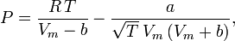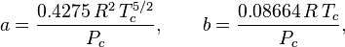
Carnot engine
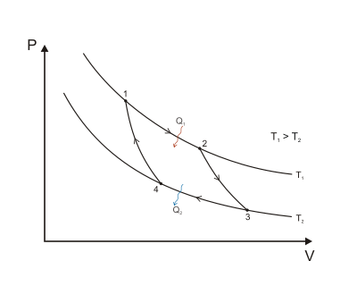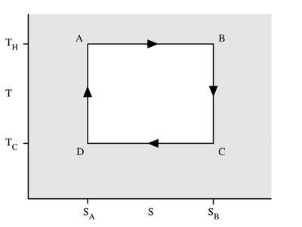
Reversible isothermal expansion of the gas at the "hot" temperature, 12, A B
Isentropic (reversible adiabatic) expansion of the gas (isentropic work output). 23, B C
$$∆S=0$$
Reversible isothermal compression of the gas at the "cold" temperature, T₂. 34, C D
Isentropic compression of the gas (isentropic work input). 41, D A
$$∆S=0$$

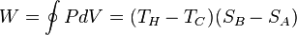
$$Q_{H}=T_{H}\left(S_{B}-S_{A}\right)=RT_{H}\ln{\frac{V_{C}}{V_{B}}}$$
$$Q_{C}=T_{C}\left(S_{B}-S_{A}\right)=RT_{C}\ln{\frac{V_{D}}{V_{A}}}$$
$$\frac{Q_{H}}{Q_{C}}=\frac{T_{H}}{T_{C}}\frac{\ln{\frac{V_{C}}{V_{B}}}}{\ln{\frac{V_{D}}{V_{A}}}}$$
$$\int_{T_{C}}^{T_{H}}{\frac{C_{V}}{R}\frac{dT}{T} }=\ln{\frac{V_{A}}{V_{B}}}=\ln{\frac{V_{D}}{V_{C}}}$$
$$\ln{\frac{V_{C}}{V_{B}}}=\ln{\frac{V_{D}}{V_{A}}}$$
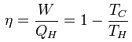

$$\frac{∆S}{R}=\frac{{C_{P}}^{ig}}{R}\ln{\frac{T}{T_{0}}}-\ln{\frac{P}{P_{0}}}$$
$${∆S}_{total}=-\frac{\left|Q_{H}\right|}{T_{H}}+\frac{\left|Q_{C}\right|}{T_{C}} \left|W\right|=\left|Q_{H}\right|-\left|Q_{C}\right|= -T_{C}∆S_{total}+|Q_{H}|(1-\frac{T_{C}}{T_{H}})$$

$$W_{ideal}= ∆H-T_{σ}∆S W_{lost}= T_{σ}∆S-Q$$
$$S_{G}= ∆S-\frac{Q}{T_{σ}}$$

H = U + PV
A = U – TS
G = H – TS

dU = TdS – PdV ${(\frac{∂T}{∂U})}_{S}=-{(\frac{∂P}{∂S})}_{V}$
dH = TdS + VdP ${(\frac{∂T}{∂P})}_{S}={(\frac{∂V}{∂S})}_{P}$
dA = -PdV – SdT ${(\frac{∂P}{∂T})}_{V}={(\frac{∂S}{∂V})}_{T}$
dG = VdP – SdT ${(\frac{∂V}{∂T})}_{P}=-{(\frac{∂S}{∂P})}_{T}$

Enthalpy as a function of T and P $dH=C_{P}dT+\left[V-T{\left(\frac{∂V}{∂T}\right)}_{P}\right]dP dH=C_{P}dT+\left(1-βV\right)VdP$
Entropy as a function of T and P $dS=C_{P}\frac{dT}{T}-{\left(\frac{∂V}{∂T}\right)}_{P}dP$ $dS=C_{P}\frac{dT}{T}-βVdP$
Internal Energy as a function of P ${(\frac{∂U}{∂P})}_{T}=-T{\left(\frac{∂V}{∂T}\right)}_{P}-P{\left(\frac{∂V}{∂P}\right)}_{T}$
Ideal gas ${dH}^{ig}={C_{P}}^{ig}dT {dS}^{ig}={C_{P}}^{ig}\frac{dT}{T}-R\frac{dP}{P}$
Alternative forms for liquids ${(\frac{∂S}{∂P})}_{T}=-βV {\left(\frac{∂H}{∂P}\right)}_{T}=\left(1-βT\right)V$

Internal Energy as function of T and V
$${\left(\frac{∂S}{∂T}\right)}_{V}=\frac{C_{V}}{T} {\left(\frac{∂U}{∂V}\right)}_{T}=T{\left(\frac{∂P}{∂T}\right)}_{V}-P$$
$$dU=C_{V}dT+\left[T{\left(\frac{∂P}{∂T}\right)}_{V}-T\right]dV dU=C_{V}dT+\left[T\frac{β}{K} -P\right]dV$$
$$dS=C_{V}\frac{dT}{T}+{\left(\frac{∂P}{∂T}\right)}_{V}dV dS= \frac{C_{V}}{T}dT+\frac{β}{K}dV$$

The Gibbs Energy as a Generating Function
$$dG=VdP-SdT$$
$$d\left(\frac{G}{RT}\right)=\frac{1}{RT}dG-\frac{G}{RT^{2}}dT=\frac{V}{RT}dP-\frac{H}{RT^{2}}dT$$
$$\frac{V}{RT}={[\frac{∂(\frac{G}{RT})}{∂P}]}_{T} \frac{H}{RT}=-T{[\frac{∂\left(\frac{G}{RT}\right)}{∂T}]}_{P}$$

Residual properties
M^{R} = M-M^{ig}
$$\frac{S^{R}}{R}= -T \int_{0}^{P}{{\left(\frac{∂Z}{∂T}\right)}_{P}}\frac{dP}{P}- \int_{0}^{P}{\left(Z-1\right)}\frac{dP}{P}$$
$$\frac{G^{R}}{RT}= \int_{0}^{P}{\left(Z-1\right)}\frac{dP}{P}$$

