Chemical Engineering 150A First Midterm Review Sheet

Fluid statics
$$\frac{dP}{dz}=-ρg$$
$$P_{2}-P_{1}=ρg\left(z_{2}-z_{1}\right)$$
$$P=ρgh+P_{0}$$
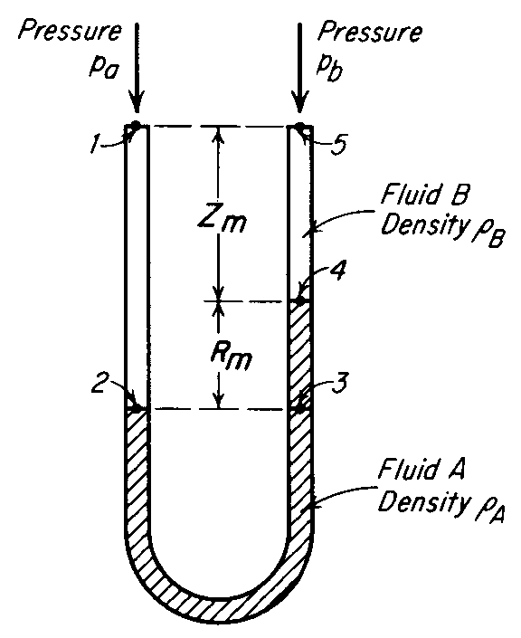2 points connected in same fluid at the same height, pressure is equal

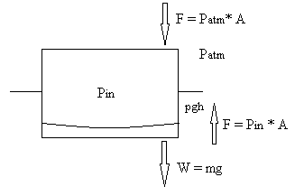 | $$W+ P_{atm}A= P_{in}A$$  $$P_{in}V_{final}=P_{atm}V_{initial}$$  $$V_{final}=V_{initial}-Ah$$  $$P_{in}\left(V_{initial}-Ah\right)=P_{atm}V_{initial}$$
Compressible fluid
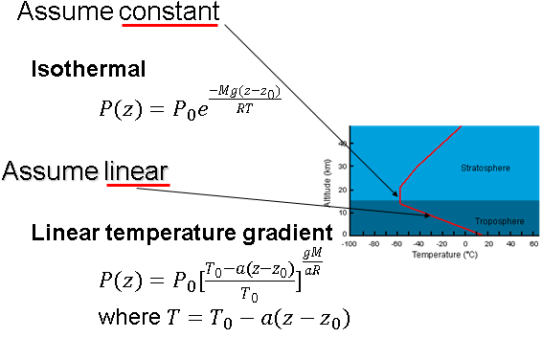
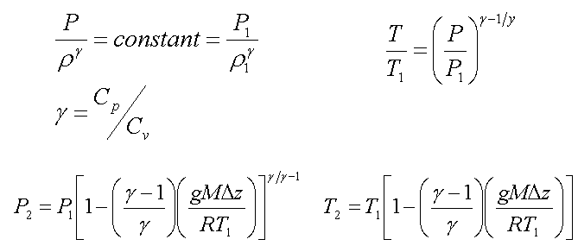

Momentum Balance
Straight tube: $F= ρ_{b}{u_{b}}^{2}S_{b}-ρ_{a}{u_{a}}^{2}S_{a}+P_{b}S_{b}-P_{a}S_{a}$
U tube: $F= ρ_{b}{u_{b}}^{2}S_{b}+ρ_{a}{u_{a}}^{2}S_{a}+P_{b}S_{b}+P_{a}S_{a}$
Velocity entering the fitting- push the fitting in the direction of velocity
Velocity leaving the fitting- push the fitting in the opposite direction of velocity

Energy Balance
Turbulent flow | $$\hat{W}=∆\frac{P}{ρ}+\frac{∆u^{2}}{2}+g∆z+ h_{f}$$
Laminar flow | $$\hat{W}=∆\frac{P}{ρ}+∆u^{2}+g∆z+ h_{f}$$

Terms | + | -
$$\hat{W}$$ | Work done on the system | Work done by the system
$$∆\frac{P}{ρ}$$ | Inlet > outlet, start with high pressure | Inlet < outlet, end with high pressure
$$∆u^{2}$$ | Start with high velocity, decelerating | Turn into high velocity, accelerating
$$g∆z$$ | Start at higher point, going into low point | Start with low point, elevation is raised
$$h_{f}$$ | Always positive, work is dissipated as friction
$$h_{f}=4f (\frac{L}{D})\frac{v^{2}}{2}$$
 | Laminar | Turbulent
Newtonian  $$Re=\frac{DρV}{μ}$$  $${Re}_{critical}=2100$$ | $$f=\frac{16}{Re}$$ | Churchill’s correlation (more accurate)  $$f=2{[{\left(\frac{8}{Re}\right)}^{12}+\frac{1}{{({\left[2.457\ln\left(\frac{1}{\left({\left(\frac{7}{Re}\right)}^{0.9}+0.27\left(\frac{k}{D}\right)\right)}\right)\right]}^{16}+{\left[\frac{37530}{Re}\right]}^{16})}^{\frac{3}{2}}}]}^{\frac{1}{12}}$$  Colebrook equation (easier)  $$\frac{1}{\sqrt{f}}=-4log⁡[\frac{k/D}{3.7}+\frac{1.255}{Re\sqrt{f}}]$$

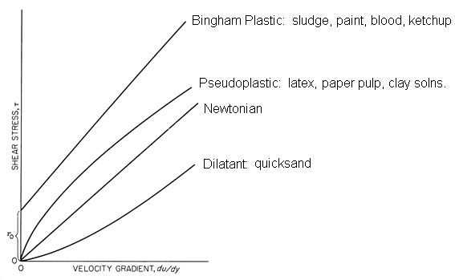
Power law fluid
$$Re=2^{3-n}{\left(\frac{n}{3n+1}\right)}^{n}\frac{v^{2-n}D^{n}ρ}{K}$$

$${Re}_{critical}=2100\frac{\left(4n+2\right)\left(5n+3\right)}{3{\left(3n+1\right)}^{2}}$$
Laminar | $$∆P=\frac{2^{n+2}{\left(\frac{3n+1}{n}\right)}^{n}LKv}{D^{n+1}}$$  $$f=\frac{16}{Re}=2^{n+1}{\left(\frac{3n+1}{n}\right)}^{n}\frac{K}{v^{2-n}D^{n}ρ}$$
Turbulent | 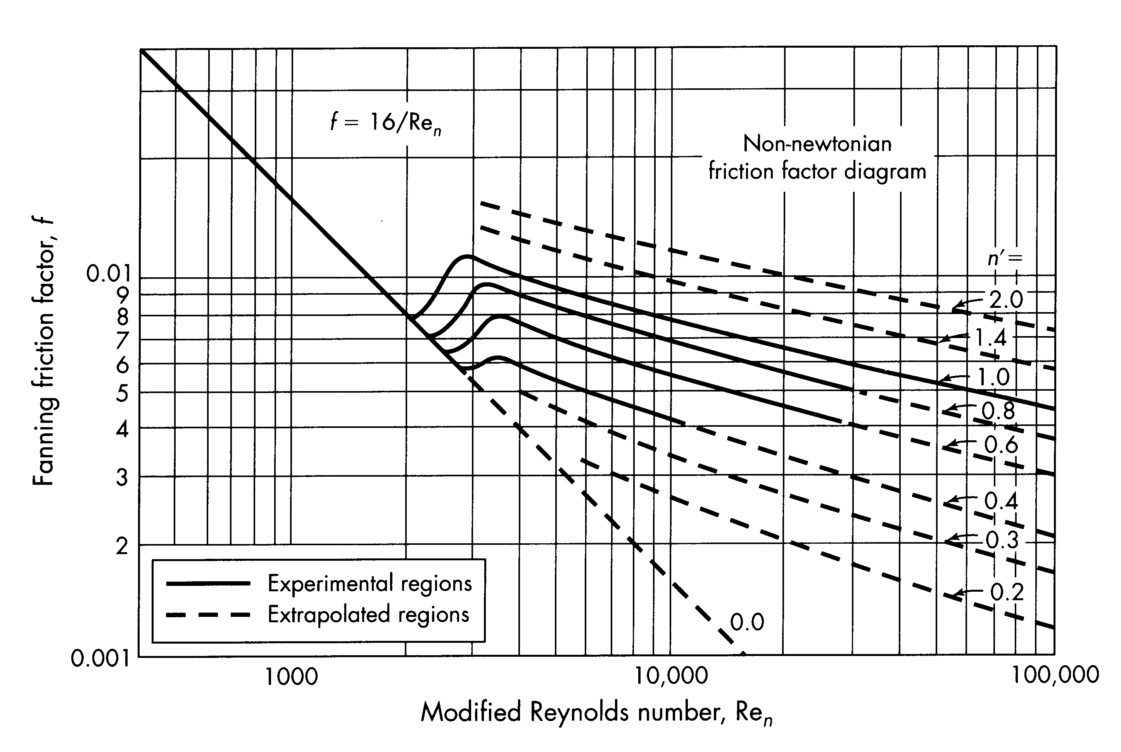
L is the length of the tube
D is the diameter of the tube
µ is the viscosity of the fluid
k is the roughness factor
Bingham Plastic | $$Re=\frac{Dρv}{μ_{∞}}$$  $$He=\frac{D^{2}ρτ_{0}}{μ_{∞}^{2}}$$
Laminar | $$f=\frac{16}{Re}\left[1+\frac{He}{6Re}-\frac{He^{4}}{3f^{3}{\left(Re\right)}^{7}}\right)$$
Turbulent | $$f={10}^{a}Re^{-0.193}$$  $$a=-1.378(1+0.146e^{-2.9*{10}^{-5}He})$$  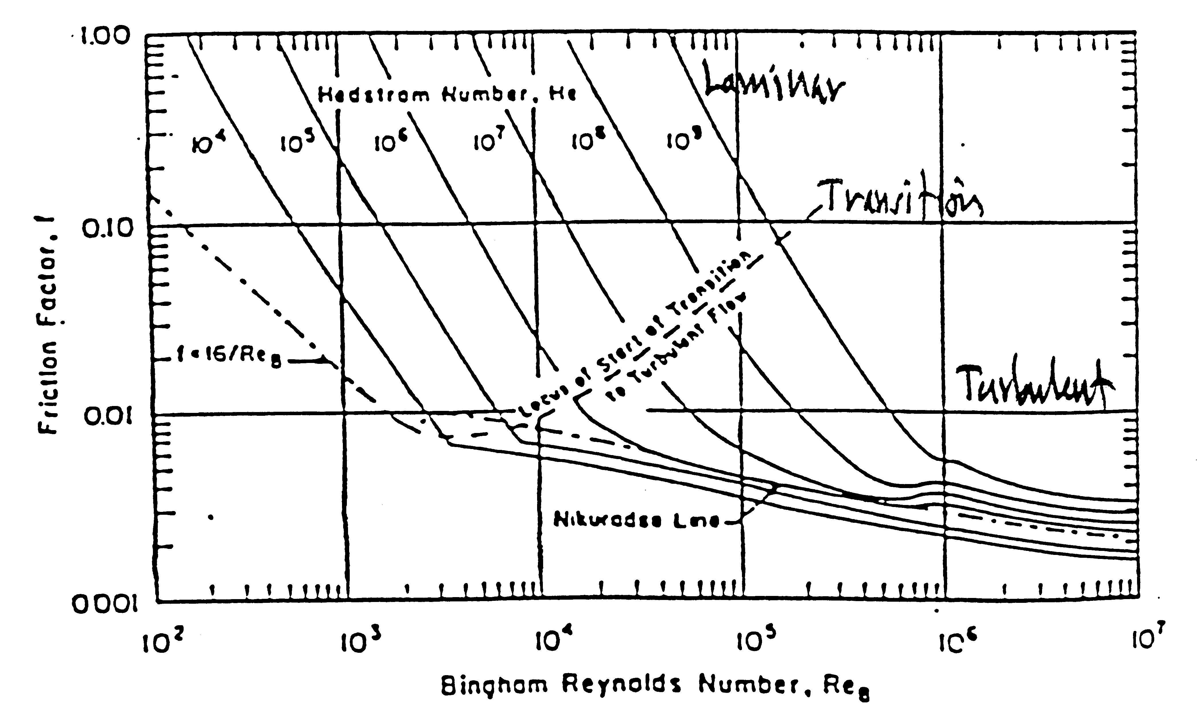

Flow through non-circular conduits
$$D_{eq}=4R_{H}=4\frac{S}{L_{p}}$$
R_{H} = hydraulic radius
S = cross-sectional area
L_{p} = wetted perimeter

Conversion
$$1 lb=453.6 g$$

$$1 in=2.54 cm$$

$$1 {ft}^{3}=7.48 gallon=28.32 L=0.02832 m^{3}$$

$$1 ft=0.3048 m=30.48 cm 1 m=3.28 ft$$

$$1 atm=1013250 \frac{dyn}{{cm}^{2}}=14.696 psi$$

$$1 dyn={10}^{-5}N= {10}^{-5}\frac{kg*m}{s^{2}}=1 \frac{g*cm}{s^{2}}=2.248*{10}^{-6}lbf$$

$$1 lbf=1 lbm*32\frac{ft}{s^{2}}$$

$$1 P= 0.100 \frac{kg}{m*s}=1 \frac{g}{cm*s}= 0.06720\frac{lb}{ft*s}$$

$$1 cP= 0.01 P=0.0006720\frac{lb}{ft*s}$$

$$1=32\frac{lbm*ft}{lbf*s^{2}}$$

$$^{o}R= ^{o}F+459.7$$

$$R=8.3145\frac{J}{mol*K}=1545.3\frac{ft*lbf}{ ^{o}R lb mol}$$

$$ρ_{H_{2}O}=1 \frac{g}{{cm}^{3}}=62.4 \frac{lbm}{{ft}^{3}}$$

$$1 Hp=745.7 W=550 \frac{ft*lbf}{s}$$

$$g=9.8 \frac{m}{s^{2}}=32.17 \frac{ft}{s^{2}}$$

