Chem 4B First Midterm Review Sheet

Systematic error- arises from a flaw in equipment or the design of an experiment
Random error- arises from controlled variables in the measurement
Accuracy- nearness to the truth Precision- agreement with one another

Propagation of error
Uncertainty in addition and subtraction 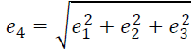
Uncertainty in multiplication and division 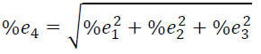

Extraction- the transfer of a solute from one phase to another
Partition coefficients- S (in phase 1) S (in phase 2) K = [S]₂ / [S]₁
Chromatography- one type of extraction where one phase is held in place while the other moves past it
The mobile phase (the solvent moving through the column) is either a liquid or a gas, and the stationary phase (the one that stays in place inside the column) is most commonly a viscous liquid chemically bonded to the inside of a capillary tube or onto the surface of solid particles packed in the column.
Fluid entering the column is called eluent, and emerging from the end of the column is called eluate. The process of passing liquid or gas through a chromatography column is called elution.

Ion-exchange chromatography
Ion exchange resins are insoluble materials that contain cations or anions that can be exchanged. The resins typically consist of a framework held together by strong chemical bonds. Positively or negatively charged functional groups are attached to this framework and each of these groups carries an oppositely charged ion, called a counter ion, which is held by electrostatic attraction. When an ion exchange resin is placed in contact with a solution containing ions, the counter ions on the resin can be replaced by an equivalent number of ions from the solution. The most common resins contain sulfonic acid groups (––SO3.H+), which are strongly acidic, or quaternary ammonium groups (––NR3 +Cl.), which are strong bases. When the sulfonated polystyrene cation exchange resin is placed in contact with a solution containing metal cations M+, the M+ ions compete with H+ for a seat on the SO3– functional groups of the resin. The ion which has the strongest attraction for the functional group will be favored in this competition reaction. The equilibrium constant for exchanging H+ with M+ depends on a number of factors, but most notably on the size and charge of the hydrated cation M+.
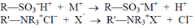

Specifics of lab 1 – IC chromatography
A chloride ion concentration of 3.0 M (pCl - = –0.5) will result in Co(II) species eluting first as cations, followed by the Cu(II) species eluting as anions. Since these complex ions are strongly colored, the progress of the separation can be followed visually.
Retention time- the time that elapses between injection of mixture onto the column and the arrival of that component at the detector
Adjusted retention time- additional time required to travel the length of the column, beyond that required by solvent
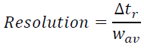 number of plates on column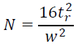

Standard solutions- solutions that contain known concentrations of analyte
Blank solutions- solutions that contain all reagents and solvents used in the analysis, but no deliberately added analyte
Matrix- everything in the sample other than analyte
Matrix effect- change in the analytical signal caused by anything in the sample other than analyte
Standard addition- known quantities of analyte are added to the unknown; from the increase in signal, we deduce how much analyte was in the original unknown

Concentration of analyte in initial solution = signal from initial solution
Concentration of analyte plus standard in final solution signal from final solution

Internal standards- a known amount of a compound, different from analyte, that is added to the unknown. Signal from analyte is compared with signal from the internal standard to find out how much analyte is present.
In standard addition, the standard is the same substance as the analyte. An internal standard is different from the analyte. Internal standard is useful for analyses in which the sample analyzed or the instrument response varies from run to run.

Metal-Chelate complexes
Metal ions are Lewis acids, accepting electron pair from ligands which are Lewis bases
Ligand- atom or group attached to a central atom in a molecule
Monodentate ligand- one that binds to a metal ion through only one atom
Multidentate ligand- one that binds to a metal ion through more than one atom
Chelating ligand- a ligand that binds to a metal through more than one atom
Chelate effect- the observation that a single multidentate ligand forms metal complexes that are more stable than those formed by several individual ligands with the same ligand atoms
Complexometric titration- one in which the reaction between analyte and titrant involves complexes formation
Formation constant, Kf = [MY^{n-4}]
[M^{n+}] [Y⁴⁻]
Conditional formation constant, Kf’ = [MY^{n-4}]
[M^{n+}] [EDTA]
Direct titration- analyte is titrated with standard EDTA
Back titration- a known excess of EDTA is added to the analyte and is then titrated with a standard solution of a second metal ion. (necessary if analyte precipitates in the absence of EDTA, if it reacts too slowly with EDTA, or if it blocks the indicator)

Specifics of lab 2- EDTA titration
Co²⁺ + EDTA²⁻ CoEDTA²⁻ + 2H⁺
The protons that are released upon complexation would change the pH of the solution.
NH₄OH (ammonia dissolved in water) and HOAc (acetic acid) serve as the buffer.
KSCN serves as the indicator, as SCN- and Co²⁺ form a blue complex
Acetone enhances the blue color.
mol of Co²⁺ original present = ( V_{EDTA}* [EDTA] – V_{Co}²⁺ _{standard} * [Co²⁺ standard] )
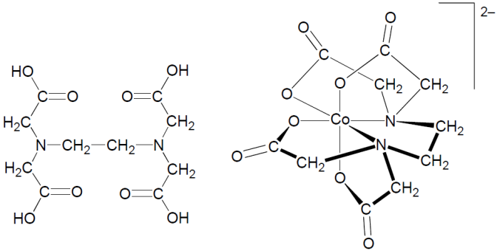
AAS/AES
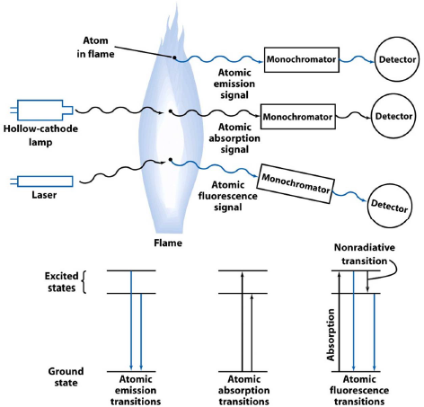

Atomic absorption spectroscopy- absorption of the light by free gaseous atoms in a plasma, flame, or furnace is used to measure the concentration of atoms
Atomic emission spectroscopy- emission of the light by thermally excited atoms in a flame or furnace is used to measure the concentration of atoms
Atomic fluorescence spectroscopy- electronic transitions of atoms in a flame, furnace, or plasma are excited by light, and the fluorescence is observed at a right angle to the incident beam

Samples are vaporized as free atoms into the light path of the spectrometer by drawing a solution into a flame. In a typical flame atomizer, all or part of the solution is sprayed as a fine mist and spread throughout the flame. A monochromator is adjusted to allow only the wavelength of an atomic line of the element for which you are analyzing onto the detector.
