Chem 4B Second Midterm Review Sheet
AAS/AES
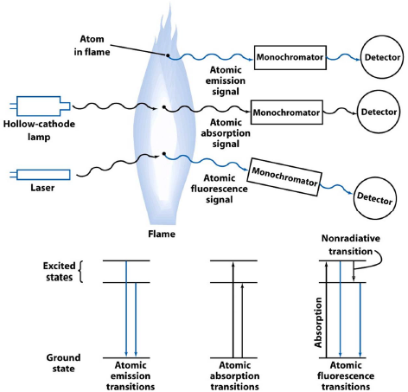

Atomic absorption spectroscopy- absorption of the light by free gaseous atoms in a plasma, flame, or furnace is used to measure the concentration of atoms
Atomic emission spectroscopy- emission of the light by thermally excited atoms in a flame or furnace is used to measure the concentration of atoms
Atomic fluorescence spectroscopy- electronic transitions of atoms in a flame, furnace, or plasma are excited by light, and the fluorescence is observed at a right angle to the incident beam

Samples are vaporized as free atoms into the light path of the spectrometer by drawing a solution into a flame. In a typical flame atomizer, all or part of the solution is sprayed as a fine mist and spread throughout the flame. A monochromator is adjusted to allow only the wavelength of an atomic line of the element for which you are analyzing onto the detector.
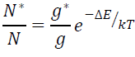

Chromatography- one type of extraction where one phase is held in place while the other moves past it
The mobile phase (the solvent moving through the column) is either a liquid or a gas, and the stationary phase (the one that stays in place inside the column) is most commonly a viscous liquid chemically bonded to the inside of a capillary tube or onto the surface of solid particles packed in the column.
Fluid entering the column is called eluent, and emerging from the end of the column is called eluate. The process of passing liquid or gas through a chromatography column is called elution.
In gas chromatography, gaseous analyte, is transported through the column by a gaseous mobile phase, called carrier gas. in gas-liquid partition chromatography, the stationary phase is a volatile liquid bonded to the inside of the column or to a fine solid support.

Comparison of retention times to standard samples run under the same column conditions is an excellent method for determining the identity of compounds in a complex mixture, such as a biological sample. A Flame Ionization Detector (FID) responds when compounds exit the column and a chromatogram of the data is generated. The peaks in the chromatogram can be measured for height or integrated to find their area. Quantitative determination of the amount of a particular compound is done through the construction of calibration curves with or without the use of an internal standard.
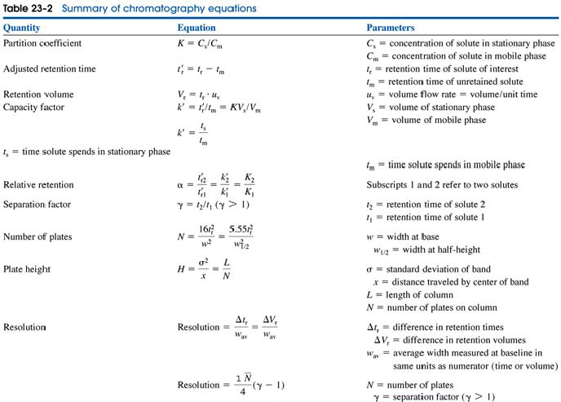

Chromatogram shows the detector response as a function of elution time.
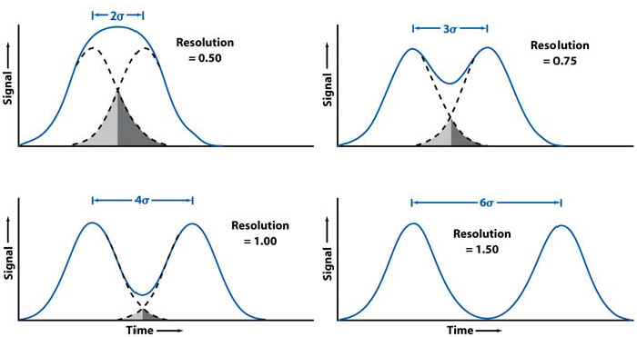
A resolution of > 1.5 is desirable.

With a longer column, resolution goes up, peak height goes down, peak width goes up, peak area stays the same.
Selected ion monitoring- mass to charge ratio can help to determine what species of ion is present
Normal-phase chromatography- polar stationary phase and a less polar solvent, in which a more polar solvent has higher eluent strength
Reversed-phase chromatography- nonpolar stationary phase and a more polar solvent, in which a less polar solvent has higher eluent strength
Eluent strength is increased by making the mobile phase more like the stationary phase. The more the eluent strength of the solvent, the more easily it displaces the solute.

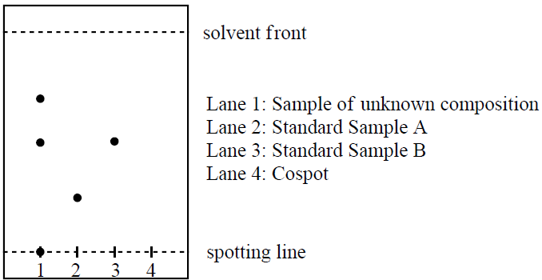
Thin layer chromatography, or TLC, is an analytical technique which allows for the rapid evaluation of the components of a mixture. This technique utilizes a TLC plate, which consists of a thin layer of a stationary phase (such as silica or alumina) bonded to the surface of an inert support material, such as plastic, aluminum, or glass. The mobile phase for this chromatographic separation is a liquid which is often referred to as the developing solvent or eluent.
The last lane on each TLC plate is a cospot lane, which contains a combined sample of all of other lanes from that plate. This allows compounds with similar but not identical retentions (Rf) values to be distinguished from each other by comparison with the individual lanes.
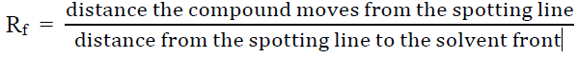
The location(s) of the analyte(s) is identified by one or more visualization techniques, such as UV light, treatment with iodine vapor, or reaction with a staining solution such as KMnO4.

A redox reaction involves transfer of electrons from one species to another.
Oxidation- loss of electrons (something is oxidized)
Reduction- gain of electrons (something is reduced)
Oxidizing agent (oxidant)- gains electrons, becomes reduced
Reducing agent (reductant)- loses electrons, becomes oxidized
q (charge, C) = n (mol) * F (Faraday’s constant, C/mol) Work = E (volts) * q (charge)
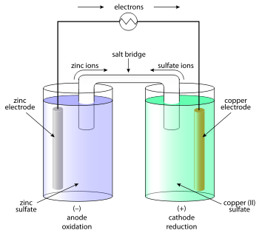
Δ G = - work = -n F E I (current) = E (voltage) / R (resistance)

M^{n+} (oxidized species) + ne⁻ M (reduced species)
m A + n B^{m+} n B + m A^{n+}
A (s) | A^{n+} (aq) || B^{m+} (aq) | B (s)

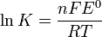

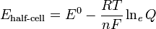

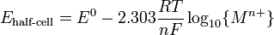

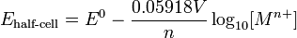 (298K)
Platinum electrode is inert, it doesn’t participate in the redox chemistry except as a conductor of electrons.
Standard hydrogen electrode (SHE)- H₂ bubbling over a catalytic Pt surface immersed in aqueous H⁺
Larger ions have larger mobility in water because it is less surrounded by water molecules. Hydrogen has the highest mobility.

