 | Electric | Magnetic
Field | E | B
Potential | V | -----------------
Force | F_{E} = Q(E + U x B) | F_{M} = IL x B
Point | E = q / 4πε₀r | -----------------
Line | E = λ / 2πε₀r | B = B = μ₀I / 2πr
Plane | E = σ / 2ε₀ | B = nμ₀I
Device | C = Aε₀ / d | L =
Voltage | V = q/C | V = -LBv
Energy | U_{E} = ½ CV² | U_{M} = ½ LI²
Dipole | P = qd U = -p • E  Τ = p x E | μ = IA U = -μ • B  τ = μ x B
Maxwell | $∮$E • dA = q_{enclosed} / ε₀  ℇ = -dф_{e} / dt | $∮$B • dA = 0  $∮$B • dl = μ₀I
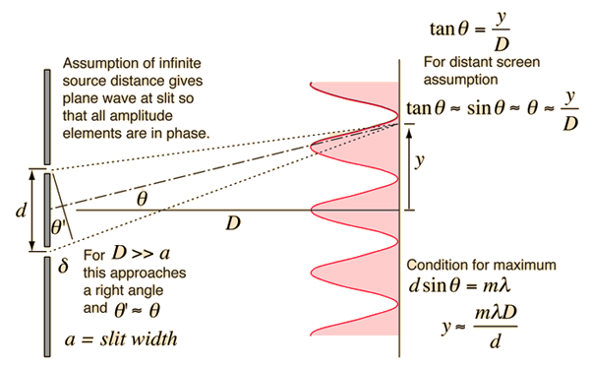
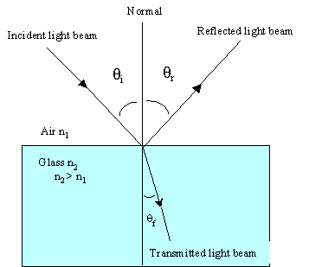
Double Slit Diffraction
Refraction/
Reflection
Mirror Ray Tracing
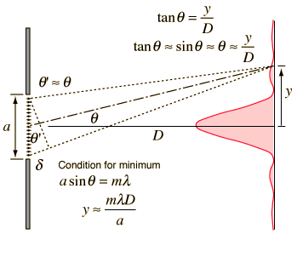

Single slit diffraction

